**ABSTRACT**

The rapid growth of online travel information imposes an increasing challenge for tourists who have to choose from a large number of travel packages to satisfy their personalized requirements. On the other side, to get more business and profit, the travel companies have to understand these preferences from different tourists and serve more attractive packages. Therefore, the demand for intelligent travel services, from both tourists and travel companies, is expected to increase dramatically. Since recommender systems have been successfully applied to enhance the quality of service for customers in a number of ﬁelds, it is natural direction to develop recommender systems for personalized travel package recommendation. It goes beyond personalized package recommendations and is helpful for capturing the latent relationships among the tourists in each travel group. It aims to make personalized travel package recommendations for the tourists. The objective of the**”** Travel package recommendation system using Data Mining Technique” is to develop a system that automates the processes and activities of a travel and the purpose is to design a system using which one can perform all operations related to traveling. Tour package Information, Online Payment and Searching Facility for Customer and also Generate Different types of Report. Services provided by travel package system are View Package, Search Package, Booking, Cancel Booking, and online Payment to travel anywhere. Using this system admin easily manage his all task related to travel packages he can manage user, manage travel packages, manage ticket booking, manage payment, view cancellation Besides offering dynamically generated tours, some Standard Tour packages have also been included. Travel Package System is an irresistible word when it comes to tour and travel packages. We offer tour and travel services including ticket bookings, holiday tour packages, and domestic tour packages. It provides the most suitably designed as well as the customized travel packages to the customers. It offers everything related to travelling services under one roof.

Today's extremely exhausting work environment dictates that individuals requires some joyful holiday. It provide stress-free joyful refreshing holidays with cost competitive and customized packages according to their requirements. We provide services in almost each and every city of India. To serve the customers need with best possible service and provide them the kind of comfort. It is care to customize tours as per customers’ requirement without reducing joy or quality of tour. People of all ages and backgrounds will come to enjoy the unique, upscale, joyful, and

refreshing environment that Travel Package Recommendation System provides. It may vary from customer to customer and packages according to their needs. Many machine learning techniques, a recommender system makes prediction based on users’ historical behaviors. Specifically, it’s to predict user preference for a set of items based on past experience. To build a recommender system, the most popular approaches Collaborative Filtering is used.

It offers new products and concepts. Keeping the effect of change of seasons on the human mind and body, we revise our itineraries regularly. This is because the comfort and the satisfaction of our customers are paramount to us. Travel Package Management offers a large range of travel opportunities. Whether you're looking for a weekend getaway to relax and indulge, a special holiday with friends and family, a trip to your favorites chills out spot or a new adventure, you've come to the right place Travel Package Management offers great deals and discounts on holiday packages and travel activities everything you need to plan, shop and book your trip. On the other side, to get more business and profit, the travel companies have to understand these preferences from different tourists and serve more attractive packages. Therefore, the demand for intelligent travel services, from both tourists and travel companies, is expected to increase dramatically. Since recommender systems have been successfully applied to enhance the quality of service for customers in a number of ﬁelds, it is natural direction to develop recommender systems for personalized travel package recommendation. The development of wireless environment tourism marketing is transfer from the traditional way to the new generation. The mobile commerce technology provides customer more directly and more timely information.

The accuracy can be improved with a better travel-tweet training dataset as well as a better travel category identification technique using Collaborative Approach. The demand for intelligent travel services, from each tourist and travel corporations, is predicted to extend dramatically. Since recommender systems are with success applied to boost the standard of service for patrons in a very range of ﬁelds, its natural direction to develop recommender systems for customized travel package recommendation.

**Chapter 1**

**INTRODUCTION**

In day-to-day life, people are interested in traveling and searching for the different tourist location for travel planning in which they are interested. Social media has come out continuous needs for automatic travel recommendation. This becomes an important problem in research and industry. Social media offers great opportunities to address many challenging problems, like GPS estimation and travel recommendation. Travelogue websites offer rich descriptions about landmarks and traveling experience written by users. Among all the applications, travel recommendation is especially attractive to many researchers because of the importance and the intrinsic relationship with people’s everyday lives. In general, a typical travel recommendation system consists of two aspects: generic recommendation and personalized recommendation . For the generic recommendation, it contains the suggested travel information for the destination given by the user when he/she is planning a trip; for example, answering the question such as I want to go to New York, what are the must-see attractions there? The personalized recommendation, on the other hand, takes user’s profile into account such that it can provide a more appropriate recommendation result matching user preferences. Recommender systems address the information overloaded problem by identifying user interests and providing personalized suggestions.

In general, there are three ways to develop recommender systems . The first one is content-based. It suggests items which are similar to those a given user has liked in the past. The second way is based on collaborative filtering. In other words, recommendations are made according to the tastes of other users that are similar to the target user. Finally, a third way is to combine the above and have a hybrid solution. for the traditional recommendation models, which do not consider the cost of travel packages, it is difficult to provide the right tour recommendation for the right tourists.

Travel Package Recommendation System provides. According to the tour packages we provide the facilities to customers such. It may vary from customer to customer and packages according to need. We offer new products and concepts from time to time. Keeping the effect of change of seasons on the human mind and body, we revise our itineraries regularly. This is because the comfort and the satisfaction of our customers are paramount to us. Travel Package Management

offer a large range of travel opportunities. Whether you're looking for a weekend getaway to relax and indulge, a special holiday with friends and family, a trip to your favorites’ chill out spot or a new adventure, you've come to the right place Travel Package Management offers great deals and discounts on holiday packages and travel activities everything you need to plan, shop and book your trip.

Planning route for the travel is an important step for a tourist to prepare his/her trip. User generated data from the social media can be processed, and used by the recommendation systems. Recommender system is a field of Information Retrieval that are widely used in our day to day applications and e-commerce sites to filter product and services according to user interest and preferences. A recommendation system analyses data such as user’s profile, demographic data, user’s past history and interest to recommend a list of products that are found suitable based on that data. When the data considered for the recommendation is user profile and their past history, it is content based recommendation system. Collaborative filtering based recommendation system recommends using both history of the user under consideration and also the history of the users who are similar to considered user . Travel Package System is an irresistible word when it comes to tour and travel packages. We offer tour and travel services including ticket bookings, holiday tour packages, domestic tour packages. We provide the most suitably designed as well as the customized travel packages to the customers. The enormous growth of web and its user base has become source for large amount of information available online. This information may be helpful for users, to suggest items or services as per their preferences. Recommender system plays the role of generating suggestions by collecting user information such as preferences, interests, and locations. The research on recommender systems gained importance after the emergence of collaborative filtering. The ubiquity of technology in both personal and travel connections infer the need for access to technical support that could help users resolve simple and complex technical issues. Recently, some of industry has begun to recognize the benefits of game based function and seek opportunities to leverage these benefits, especially with respect to gaming for the benefit of the corporation. The main aim of using personalization techniques is to generate customized recommendation according to the user preferences and interests . The recommender system has an objective to filter unwanted information and to provide specific results for the particular user.. In the travel recommender systems, proposed model learns the user preferences and generates places

of attractions according to the user interests. This paper focuses on the recommender systems and their application in tourism . Travel Package Management provides an outsized vary of travel opportunities. whether or not you are looking for a weekend getaway to relax and indulge, a special vacation with friends and family, a visit to your favorites’ relax spot or a replacement journey, you have return to the correct place Travel Package Management offers nice deals and discounts on vacation packages and travel activities everything you wish to arrange, search and book your trip.

In general, there are three ways to develop recommender systems. The first one is content-based. It suggests items which are similar to those a given user has liked in the past. The second way is based on collaborative filtering. In other words, recommendations are made according to the tastes of other users that are similar to the target user. Finally, a third way is to combine the above and have a hybrid solution. for the traditional recommendation models, which do not consider the cost of travel packages, it is difficult to provide the right tour recommendation for the right tourists.

This project investigated the use of context-aware mobile computing using visitors of the Mawson Lakes campus based at the University of South Australia and the North Terrace estate in the Adelaide city Centre. Recommender Systems RSs are decision support tools aimed at addressing the information overload problem, providing product and service recommendations personalized to the user's needs and preferences at a particular request context. However, existing recommendation technologies have not been developed specifically for mobile users; and this chapter shows that recommendation techniques developed for the wired web must be adapted to the mobile environment in order to better exploit the available information, and provide software tools usable on mobile devices.

Recommender systems cope with the information overload problem by providing a user with personalized recommendations adapting this selection to the Can be easily accessed using mobile devices, such as a phone with mobile Internet connection capability. However, this information can easily overwhelm a user because of the large number of information items to be shown and the limited screen size in the mobile device. Recommender systems are Nowadays travel and tourism Web sites store and offer a large volume of travel related information and services People of all ages and backgrounds will come to enjoy the unique, upscale, joyful, and refreshing environment that Travel Package Recommendation System provides. According to the tour

packages we provide the facilities to customers such. It may vary from customer to customer and packages according to need. We offer new products and concepts from time to time. Keeping the effect of change of seasons on the human mind and body, we revise our itineraries regularly. This is because the comfort and the satisfaction of our customers are paramount to us. Travel Package Management offer a large range of travel opportunities. Whether you're looking for a weekend getaway to relax and indulge, a special holiday with friends and family, a trip to your favorites chill out spot or a new adventure, you've come to the right place Travel Package Management offers great deals and discounts on holiday packages and travel activities everything you need to plan, shop and book your trip. The rapid growth of mobile technologies has placed increased focus on context-aware computing, which refers to a program or application feature that changes, depending on the environmental conditions of the user throughout the operation of the application.

**1.1 Data Mining Technique**

Data mining is the process of analyzing hidden patterns of data according to different perspectives for categorization into useful information, which is collected and assembled in common areas, such as data warehouses, for efficient analysis, data mining algorithms, facilitating business decision making and other information requirements to ultimately cut costs and increase revenue. Data mining is also known as data discovery and knowledge discovery.

**1.1.1 Collaborative Filtering Technique**

Many machine learning techniques, a recommender system makes prediction based on users’ historical behaviors. Specifically, it’s to predict user preference for a set of items based on past experience. To build a recommender system, the most two popular approaches Collaborative Filtering.

**Collaborative Filtering** on the other hand, doesn’t need anything else except users’ historical preference on a set of items. Because it’s based on historical data, the core assumption here is that the users who have agreed in the past tend to also agree in the future. In terms of user preference, it usually expressed by two categories. **Explicit Rating**, is a rate given by a user to an item on a sliding scale. This is the most direct feedback from users to show how much they like an item. **Implicit Rating**, suggests users preference indirectly, such as page views, clicks, at collaborative filtering that is a traditional and powerful tool for recommender systems.

**Chapter 2**

**LITERATURE REVIEW**

In a recent years Tourism and Travel stores offering a huge quantity of services and traveling information by online. Additionally, this huge volume of information smoothly accessed by electronic devices, like phone, computer with the availability of internet connection. When tourists are visiting any cities, most of them aimed to explore the interesting fact or things about the places and events.

Mayuri D. A swale proposed system uses the travelogues and photos of social media which map each user and routes description to the topical package area to induce user topical package model and route topical package model. To suggest personalized POI sequence, first famous routes are stratified as per the similarity between user package and route package.

Yong Ge study of cost-aware tour recommendation. Along this line, we develop two cost ware latent factor models to recommend travel packages by considering both the travel cost and the tourist’s interests.

Yu Zheng proposed system, using the GPS trajectories generated by multiple users, we mined interesting locations and classical travel sequences within a given geospatial region. A HITS-based model is proposed to infer a user’s travel experience and the interest of a location considering method showed clear advantages beyond rank-by-count and rank-by-frequency by providing a better presentation ability and ranking performance.

Shohei Jiang presents a personalized travel sequence recommendation from both travelogues and community-contributed photos and the heterogeneous metadata (e.g., tags, geo-location, and date taken) associated with these photos. Unlike most existing travel recommendation approaches, our approach is not only personalized to user’s travel interest but also able to recommend a travel sequence rather than individual Points of Interest (POIs). To recommend personalized POI sequence, first, famous routes are ranked according to the similarity between user package and route package. Then top ranked routes are further optimized by social similar users’ travel records.

Nikos Mamalis [ propose effective techniques for discovering the periodic patterns and their descriptive spatial regions from a long history of object movements. A top-down technique (STPMine2), in specific, is very efficient, having cost comparable to (ineffective) methods for event sequence data.

Logesh Ravi and Subramaniyaswamy Vairavasundaram proposed a location recommendation system based on social pertinent trust walker (SPTW) and compared the results with the existing baseline random walk models. Later, enhanced the SPTW model for group of users’ recommendations.

Ling Xing proposed model takes into consideration the location, which defines the geographical boundaries of recommended items. The model’s results represent both the popularity of all social users, but also the individual interest. Thus it serves as a personalized recommendation model. Experimental results on real-life data show that our model exhibits higher accuracy than other relevant recommendation system.

Hassan Takagi proposed a distributed cooperative approach for location privacy in LBS based on k-anonymity. In research presented approach needs neither a trusted third party nor users to trust each other. By using cryptographic schemes, user can learn whether there are at least k users including himself/herself in the query area. The research shows simple scenario where user and location providers are honest-but-curious and then we progressively extend our protocol to deal with scenarios where entities may collude with each other. Moreover, we analyze possible threats.Joseph Coelho [this study explores the use of twitter data to personalize travel recommendations. A machine learning classification model is used to identify travel related tweets. The travel tweets are then used to personalize recommendations regarding places of interest for the user. The proposed model lists ’n’ places of interest from each category in proportion to the travel category score generated by the model.

In our approach, the overall model of a recommendation session is logically divided into three phases: 1) initialization, 2) interaction and adaptation, and 3) retaining. Given a user for a product recommendation, the system builds the initial representation of the user's query. Then, the system finds the products most suitable to the initial query, and recommends them to the user. Given these recommendations the user can browse and evaluate them. Then the user may critique the

recommended products, e.g., “This product is too expensive for me”. This user’s evaluation helps the system to adapt (update) the current understanding of the user's needs and preferences encoded in the user-query representation. These steps, i.e., the system's recommendation, iterate until. when the user is satisfied with one of the recommended products or when she terminates the for a product recommendation, the system builds the initial representation of the user's query. Then, the system finds the products most suitable to the initial query, and recommends them to the user. Given these recommendations the user can browse and evaluate them. Then the user may critique the recommended products, e.g., “This product is too expensive for me”. This user’s evaluation helps the system to adapt (update) the current understanding of the user's needs and preferences encoded in the user-query representation.

**2.1 Limitations of Existing System**

* The existing system having a package recommendation problem.
* The user interest not considers in the system.
* It directly shown the packages and it’s very difficult for user to choose the specific package from the collection.

**Chapter 3**

**SYSTEM ANALYSES AND DESIGN**

**3.1 Problem Analysis**

“To develop a system that automates the processes and activities of a travel and the purpose is to design a system using which various packages recommend to user by system.”

The aim of this project is to improve the performance of travel package recommendation system. This project is going to develop a framework and a better web solution which work in two phase. Firstly, it gets the input from the user as its profile information and secondly it will apply an appropriate technique to recommend the specific package.

**3.2Proposed Work**

**3.2.1Module**

This project has two main modules for proper functioning.

* **Admin:** Admin can add a package, manage package and also view feedback and enquiry.
* **User :** User can view information of available travel package and search various packages.

**Module Description**

The system should be designed in such a way that only authorized people should be allowed to access some particular modules. The records should be modified by only administrators and no one else. The user should always be in control of the application and not the vice versa.

The user interface should be consistent so that the user can handle the application with ease and speed. The application should be visually, conceptually clear.

**3.2.1.1 ADMINISTRATOR MODULE:**

* **Add Package:**

This module provides administrator related functionality. Administrator manages all information and has access rights to add, delete, edit and view the data related to places, travels, routes, bookings, etc.

Using this system admin easily manage his all task related to travel packages he can manage user, manage travel packages, manage ticket booking, manage payment, view cancellation Besides offering dynamically generated tours, some Standard Tour packages have also been included. The admin add package in the all sides east west north and south destinations of travel routes.

* **Update Package:**

In this module admin can update existing travel package in the in the system if any changes is happened in the any package of travelling and also update customer information if any changes is made by customer in his booking, travelling destination or cancellation of booking all this data can be manage and maintained by the admin itself very quickly using our system.

* **Delete Package:**

In this module admin can delete existing package or newly added package if any change is occurred in the traveling package management and also delete information related to the customer.

* **View Customer Information:**

In this module admin can view the package selected by the customer and also make booking of the package selected for that customer.

* **Company registration:**

In this module admin can do companies registration, company log, company wise travel packages log.

* **DSS Reporting:**

In this module admin can manage most searched/viewed report, most recommended travel packages, user interest.

**3.2.1.2 COMPANY ADMIN MODULE:**

* Package Category Management:

In this module company admin can manage package category.

* Category wise Travel Package Management:

In this module company admin can manage category wise travel packages.

* Customer Enquiries Management:

In this module company admin can manage customer enquiries.

* DSS Reporting:

In this module company admin can manage most required packages report, user interest, users need, performance mining report.

**3.2.1.3 USER MODULE:**

* Login:

After login in the system, user can do Online Registration for travelling, got Tour Package Information, Ticket Booking, Online Payment and Searching Facility for Customer. Services provided by travel package recommendation system are View Package, Search Package, Booking, Cancel Booking, online Payment to travel anywhere.

* View the package:

In this module user can view the four buttons after login east, west, north, south and after click on any button user can see the packages and places related to the selected direction.

* Registration for package:

After login in the system, user can do Online Registration for travelling, got Tour Package Information, Ticket Booking, Online Payment and Searching Facility for Customer. Services provided by travel package system are View Package, Search Package, Booking, Cancel Booking, online payment to travel anywhere.

* 1. **Flow Chart Diagram**

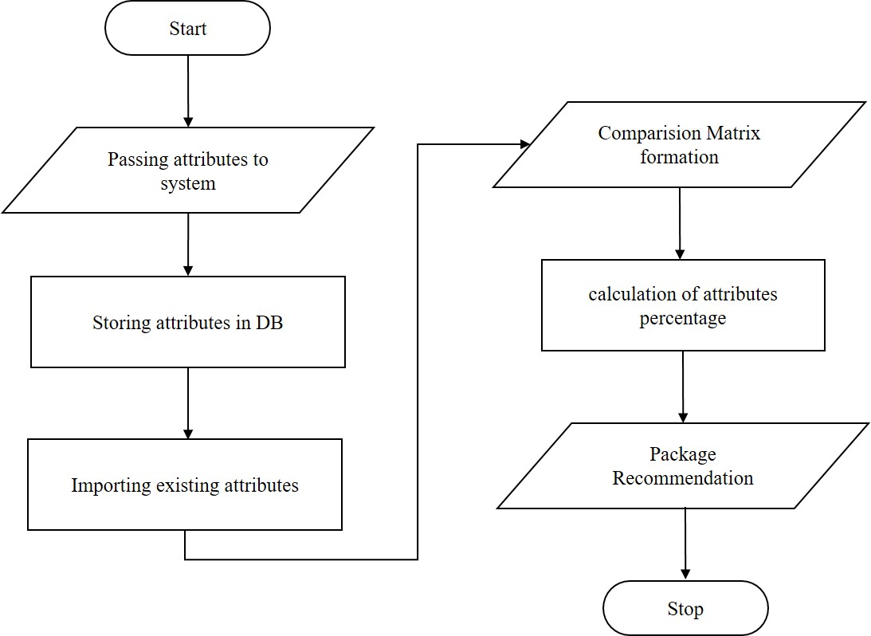

**Figure3.1 Admin System Flow Diagram**

* 1. **Advantage**
* Manual operator control:Manual operator control is use for accessing

complaints information.

* User friendly.
* Placed Complaints Easily by user.

**3.4 Input Output Specification**

**3.4.1 Hardware Requirement:**

* Processor : Intel Core Duo 2.0 GHz or more
* RAM : 1 GB or More
* Hard disk : 80 GB or more
* Monitor : 15” CRT or LCD monitor
* Keyboard : Normal or Multimedia
* Mouse : Compatible mouse

**3.4.2 Software Requirement:**

* Front End : ASP .Net
* Backend : SQL Server
* Framework : Dot net 4.0
* Web Server : IIS

**3.5 Technologies Basic**

**3.5.1 .Net framework 4.0**

Microsoft .NET Framework is a complex technology that provides the infrastructure for building, running, and managing next generation applications. In a layered representation, the .NET Framework is a layer positioned between the Microsoft Windows operating system and your applications. .NET is a platform but also is defined as a technology because it is composed of several parts such as libraries, executable tools, and relationships and integrates with the operating system. Microsoft Visual Studio 2010 relies on the new version of the .NET Framework 4.0. Visual Basic 2010, C# 4.0, and F# 2010 are .NET languages that rely on and can build applications for the .NET Framework 4.0.

The .NET Framework is an application development platform that provides services for building, deploying, and running desktop, web, and phone applications and web services. It consists of two major components: the common language runtime (CLR), which provides memory management and other system services, and an extensive class library, which includes tested, reusable code for all major areas of application development.

**3.5.2 ASP.net**

ASP.NET is more than the next version of Active Server Pages (ASP); it provides a unified Web development model that includes the services necessary for developers to build enterprise-applications. While ASP.NET is largely syntax compatible with ASP, it also provides a new programming model and infrastructure for more scalable and stable applications that help provide greater protection. You can feel free to augment your existing ASP applications by incrementally adding ASP.NET functionality to them.

ASP.NET is a compiled, .NET-based environment; you can author applications in any .NET compatible language, including Visual Basic .NET, C#, and JScript .NET. Additionally, the entire .NET Framework is available to any ASP.NET application. Developers can easily access the benefits of these technologies, which include the managed common language runtime environment, type safety, inheritance, and so on.[1]

ASP.NET has been designed to work seamlessly with WYSIWYG HTML editors and other programming tools, including Microsoft Visual Studio .NET. Not only does this make Web development easier, but it also provides all the benefits that these tools have to offer, including a GUI that developers can use to drop server controls onto a Web page and fully integrated debugging support. Developers can use Web Forms or XML Web services when creating an ASP.NET application, or combine these in any way they see fit. Each is supported by the same infrastructure that allows you to use authentication schemes cache frequently used data, or customize your application's configuration, to name only a few possibilities.

Web Forms allow you to build powerful forms-based Web pages. When building these pages, you can use ASP.NET server controls to create common UI elements, and program them for common tasks. These controls allow you to rapidly build a Web Form out of reusable built-in or custom components, simplifying the code of a page. For more information, see Web Forms Pages. For information on how to develop ASP.NET server controls, see Developing ASP.NET Server Controls.

**3.5.3 XML**

An XML Web service provides the means to access server functionality remotely. Using XML Web services, businesses can expose programmatic interfaces to their data or business logic, which in turn can be obtained and manipulated by client and server applications. XML Web services enable the exchange of data in client-server or server-server scenarios, using standards like HTTP and XML messaging to move data across firewalls. XML Web services are not tied to a particular component technology or object-calling convention. As a result, programs written in any language, using any component model, and running on any operating system can access XML Web services. For more information, see XML Web Services Created Using ASP.NET and XML Web Service Clients.

Each of these models can take full advantage of all ASP.NET features, as well as the power of the .NET Framework and .NET Framework common language runtime. These features If you have ASP development skills, the new ASP.NET programming model will seem very familiar to you. However, the ASP.NET object model has changed significantly from ASP, making it more structured and object-oriented. Unfortunately, this means that ASP.NET is not fully backward compatible;

Almost all existing ASP pages will have to be modified to some extent in order to run under ASP.NET. In addition, major changes to Visual Basic .NET mean that existing ASP pages written with Visual Basic Scripting Edition typically will not port directly to ASP.NET. In most cases, though, the necessary changes will involve only a few lines of code. For more information, see Migrating from ASP to ASP.NET.

Accessing databases from ASP.NET applications is an often-used technique for displaying data to Web site visitors. ASP.NET makes it easier than ever to access databases for this purpose. It also allows you to manage the database from your code. For more information, see Accessing Data with ASP.NET

ASP.NET provides a simple model that enables Web developers to write logic that runs at the application level. Developers can write this code in the Global. Sax text file or in a compiled class deployed as an assembly. This logic can include application-level events, but developers can easily extend this model to suit the needs of their Web application. For more information, see ASP.NET Applications.

ASP.NET provides easy-to-use application and session-state facilities that are familiar to ASP developers and are readily compatible with all other .NET Framework APIs. For more information, see ASP.NET State Management.

For advanced developers who want to use APIs as powerful as the ISAPI programming interfaces that were included with previous versions of ASP, ASP.NET offers the Righthander and Attojoule interfaces. Implementing the Righthander interface gives you a means of interacting with the low-level request and response services of the IIS Web server and provides functionality much like ISAPI extensions, but with a simpler programming model. Implementing the Attojoule interface allows you to include custom events that participate in every request made to your application. For more information, see HTTP Runtime Support.

ASP.NET takes advantage of performance enhancements found in the .NET Framework and common language runtime. Additionally, it has been designed to offer significant performance improvements over ASP and other Web development platforms. All ASP.NET code is compiled, rather than interpreted, which allows early binding, strong typing, and just-in-time (JIT) compilation to native code, to name only a few of its benefits. ASP.NET is also easily factorable, meaning that developers can remove modules (a session module, for instance) that are not relevant to the application they are developing. ASP.NET also provides extensive caching services (both built-in services and caching APIs). ASP.NET also ships with performance counters that developers and system administrators can monitor to test new applications and gather metrics on existing applications. For more information, see ASP.NET Caching Features and ASP.NET Optimization.

Writing custom debug statements to your Web page can help immensely in troubleshooting your application's code. However, they can cause embarrassment if they are not removed. The problem is that removing the debug statements from your pages when your application is ready to be ported to a production server can require significant effort. ASP.NET offers the Trace Context class, which allows you to write custom debug statements to your pages as you develop them. They appear only when you have enabled tracing for a page or entire application. Enabling tracing also appends details about a request to the page, or, if you so specify, to a custom trace viewer that is stored in the root directory of your application. For more information, see ASP.NET Trace.

The .NET Framework and ASP.NET provide default authorization and authentication schemes for Web applications. You can easily remove, add to, or replace these schemes, depending upon the needs of your application. For more information, see Securing ASP.NET Web Applications.

ASP.NET configuration settings are stored in XML-based files, which are human readable and writable. Each of your applications can have a distinct configuration file and you can extend the configuration scheme to suit your requirements. For more information, see ASP.NET Configuration.

Applications are said to be running side by side when they are installed on the same computer but use different versions of the .NET Framework. To learn how to use different versions of ASP.NET for separate applications on your server, see Side-by-Side Support in ASP.NET

IIS 6.0 uses a new process model called worker process isolation mode, which is different from the process model used in previous versions of IIS. ASP.NET uses this process model by default when running on Windows Server 2003. For information about how to migrate ASP.NET process model settings to worker process isolation mode, see IIS 6.0 Application Isolation Modes.

**3.5.4 VB.net**

Unless you have been living under a rock for the past year, you must have heard of .net (“dot net”) by now. What is .net? Is it a new operating environment? Is it a new language? Is it a new way of developing distributed applications? The answer is “Yes”: .net is all of these things and more. The .net world was created by Microsoft to allow users to have access to their information, files, or programs anywhere, anytime, and on any platform or device.[10]

When Microsoft introduced the first Windows operating system, it took application development and system design to a new level: multi-tasking. With each new version of Windows, multi-tasking has been driven more towards distributed processing and .net is the next step.

Visual Studio.net has an entirely new, object-oriented framework. In this paper I will introduce you to some of features in Visual Studio.net, however, I will focus mostly on Visual Basic.net and draw some comparisons to its predecessor VB 6. The reader of this paper will not be able to start developing code in Visual Basic.net after reading, but should have a high-level view of the changes in Visual Basic.net and how they differ from previous versions.

**3.5.5 .Net Framework Components**



Figure 3.5.5: Overview of the .net Framework

As shown in Figure 2.1, Visual Basic sits at the top of the framework (along with the other languages in Visual Studio.net). Below that is the Common Language Specification (CLS). This specification is a set of rules that govern the minimum language features that must be supported to ensure that a language will interoperate with other CLS-compliant components and tools. As long as a language conforms to the CLS, it is guaranteed to work with the CLR. In this way, when third-party compilers target the .net framework, as long as they conform to the CLS, the code is guaranteed to work.

You might also notice that VB is now and “equal” or peer of C++, C# and any other language that is .net compliant. Visual Basic.net shares the same variable types, arrays, user-defined types, classes, graphical forms, visual controls and interfaces as these other languages.

**3.5.6 Web Services**

Web Services provide a Web-enabled user interface with tools that include various HTML controls and Web controls. Forms creating using Web Services are the same as forms created for a Windows application. The code behind a Web form is the same as the code behind a Windows form. The markup language that is used by Web forms is still there, but the Web form applications generate it for you.

### 3.5.7 User Interface

At the same level as Web Services is the User Interface. The User Interface is where Windows forms live. It also provides code for drawing to the screen, printing, rendering text and displaying images

### 3.5.8 Data and XML

Both Web Services and the User Interface sit on top of the Data and XML block. As you will learn later in this paper, XML (or extensible markup language) plays just as important of a role as data. XML is used to provide a text view of data that can be shared between services on the same PC or passed through a firewall to a web server across the country using SOAP (more on SOAP a little later.

**3.5.9 Base Class Library**

The base class library (BCL) is underneath the Data and XML block. This area is the origin for the base class of all .net programs. Everything in Visual Basic.net is an object, and all objects originate from a class named system. The BCL also provides collections, localization, text objects, interoperability with non-.net code and ActiveX controls and a variety of other services.

**3.5.10 Ajax**

Ajax is a set of programming techniques or a particular approach to Web programming. These programming techniques involve being able to seamlessly update a Web page or a section of a Web application with input from the server, but without the need for an immediate page refresh. This doesn't mean that the browser doesn't make a connection to the Web server. What differs in the Ajax model is that the position at which the page is updated and moved.

Ajax shorthand for asynchronous JavaScript and XML is a group of interrelated web development methods used on the client-side to create interactive web applications. With Ajax, web applications can retrieve data from the server asynchronously in the background without interfering with the display and behavior of the existing page. Data is usually retrieved using the XML Http Request object. Despite the name, the use of XML is not needed, and the requests need not be asynchronous. Like DHTML and LAMP, Ajax is not one technology, but a group of technologies. Ajax uses a combination of HTML and CSS to mark up and style information. The DOM is accessed with JavaScript to dynamically display, and to allow the user to interact with the information presented. JavaScript and the XML Http Request object provide a method for exchanging data asynchronously between browser and server to avoid full page reloads.

To improve the user's experience, we need to add some extra capabilities to the traditional page-based interface design. We want our user's page to be interactive, responding to the user's actions with revised content, and be updated without any interruptions for page loads or screen refresh. To achieve this, Ajax builds an extra layer of processing between the web page and the server. This layer often referred to as an Ajax Engine or Ajax Framework, intercepts requests from the user and in the background handles server communications quietly, unobtrusively, and asynchronously. By this we mean that server requests and responses no longer need to coincide with particular user actions but may happen at any time convenient to the user and to the correct operation of the application. The browser does not freeze and await the completion by the server of the last request but instead lets the user carry on scrolling, clicking, and typing in the current page.

**3.6 MSSQL Server 2005**

Microsoft SQL Server is an application used to create computer databases for the Microsoft Windows family of server operating systems. It provides an environment used to generate databases that can be accessed from workstations, the web, or other media such as a personal digital assistant (PDA).

SQL Server 2005 (formerly codenamed "Yukon") released in October 2005. It included native support for managing XML data, in addition to [relational data](https://en.wikipedia.org/wiki/Relational_database). For this purpose, it defined an xml [data type](https://en.wikipedia.org/wiki/Data_type) that could be used either as a data type in database columns or as [literals](https://en.wikipedia.org/wiki/Literal_(computer_science)) in queries. XML columns can be associated with [XSD](https://en.wikipedia.org/wiki/XSD) schemas; XML data being stored is verified against the schema. XML is converted to an internal binary data type before being stored in the database. Specialized indexing methods were made available for XML data. XML data is queried using [XQuery](https://en.wikipedia.org/wiki/XQuery); SQL Server 2005 added some extensions to the [T-SQL](https://en.wikipedia.org/wiki/T-SQL) language to allow embedding XQuery queries in T-SQL. In addition, it also defines a new extension to XQuery, called XML DML that allows query-based modifications to XML data. SQL Server 2005 also allows a database server to be exposed over [web services](https://en.wikipedia.org/wiki/Web_service) using [Tabular Data Stream](https://en.wikipedia.org/wiki/Tabular_Data_Stream) (TDS) packets encapsulated within [SOAP (protocol)](https://en.wikipedia.org/wiki/SOAP_(protocol)) requests. When the data is accessed over web services, results are returned as XML. [Common Language Runtime](https://en.wikipedia.org/wiki/Common_Language_Runtime) (CLR) integration was introduced with this version, enabling one to write SQL code as Managed Code by the CLR. For relational data, [T-SQL](https://en.wikipedia.org/wiki/T-SQL) has been augmented with error handling features (try/catch) and support for recursive queries with CTEs (Common Table Expressions). SQL Server 2005 has also been enhanced with new indexing algorithms, syntax and better error recovery systems. Data pages are [check summed](https://en.wikipedia.org/wiki/Checksum) for better error resiliency, and optimistic concurrency support has been added for better performance. Permissions and access control have been made more granular and the query processor handles concurrent execution of queries in a more efficient way. Partitions on tables and indexes are supported natively, so scaling out a database onto a [cluster](https://en.wikipedia.org/wiki/Cluster_(computing)) is easier. SQL CLR was introduced with SQL Server 2005 to let it integrate with the .NET Framework.

Microsoft SQL Server is a [relational database management system](http://en.wikipedia.org/wiki/Relational_database_management_system) developed by [Microsoft](http://en.wikipedia.org/wiki/Microsoft). As a database, it is a software product whose primary function is to store and retrieve data as requested by other software applications, be it those on the same computer or those running on another computer across a network (including the Internet). There are at least a dozen different editions of Microsoft SQL Server aimed at different audiences and for different workloads (ranging from small applications that store and retrieve data on the same computer, to millions of users and computers that access huge amounts of data from the Internet at the same time). Its primary [query languages](http://en.wikipedia.org/wiki/Query_language) are [T-SQL](http://en.wikipedia.org/wiki/Transact-SQL) and [ANSI SQL](http://en.wikipedia.org/wiki/SQL).

**3.7 Architecture of Proposed System**

The system should be designed in such a way that only authorized people should be allowed to access some particular modules. The records should be modified by only administrators and no one else. The user should always be in control of the application and not the vice versa. The user interface should be consistent so that the user can handle the application with ease and speed. The application should be visually, conceptually clear.

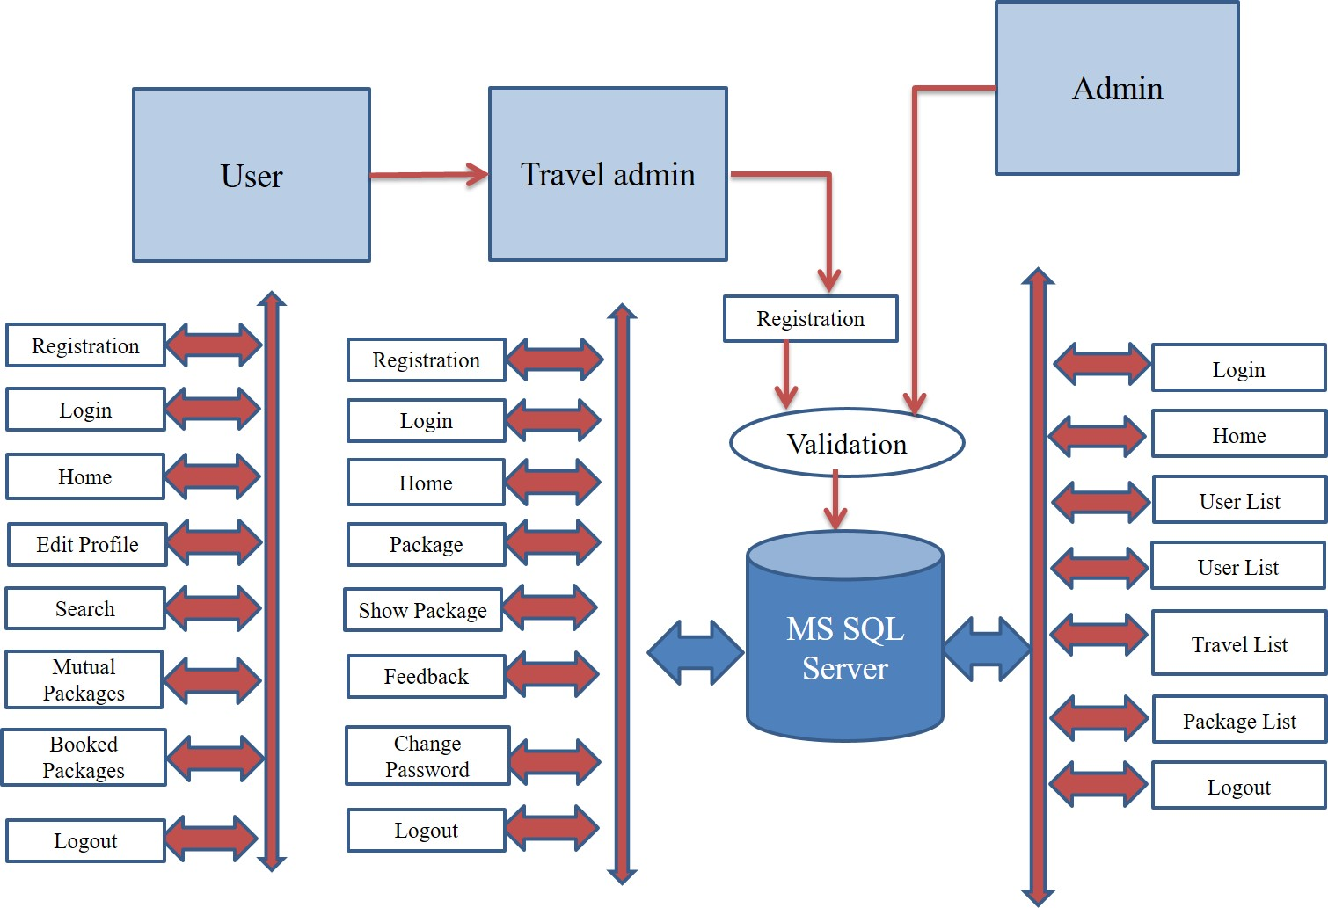

**Fig1. Architecture of Proposed work.**

As shown in figure shows the flowchart of proposed model. In proposed model there are two modules admin module and user modules. In admin model, admin have some functions like admin can add new packages admin have rights to view packages and update package. Similarly, in user model, users have some functions like search, book package users can check notifications, users can change their profile.

**3.8 System Design**

**3.8.1 Data Flow Diagram [D.F.D]**

The data flow diagrams are pictorial or graphical representation of the outline of the system study. The data flow diagram covers all the processes and data storage area which takes place during any transaction in the system. The data flow diagrams are functionally divided into context level, Zero level and First level data flow diagrams.

**Symbols Used In DFDs**

**3.8.1.1 Process:** Here flow of data is transformed. e.g. Purchase of currencies, update inventory file, etc.

**3.8.1.2External Entity:** A source or destination of data which is external to the system. e.g. Public, Dealer etc.

**3.8.1.3A data flow:** It is packet of data. It may be in the form of document, letter

,

**3.8.1.4Data store:** Any store data but with no reference to the physical method of storing.



**Figure 3.1 Data flow diagram of System**

**3.8.2 Use Case Diagram**

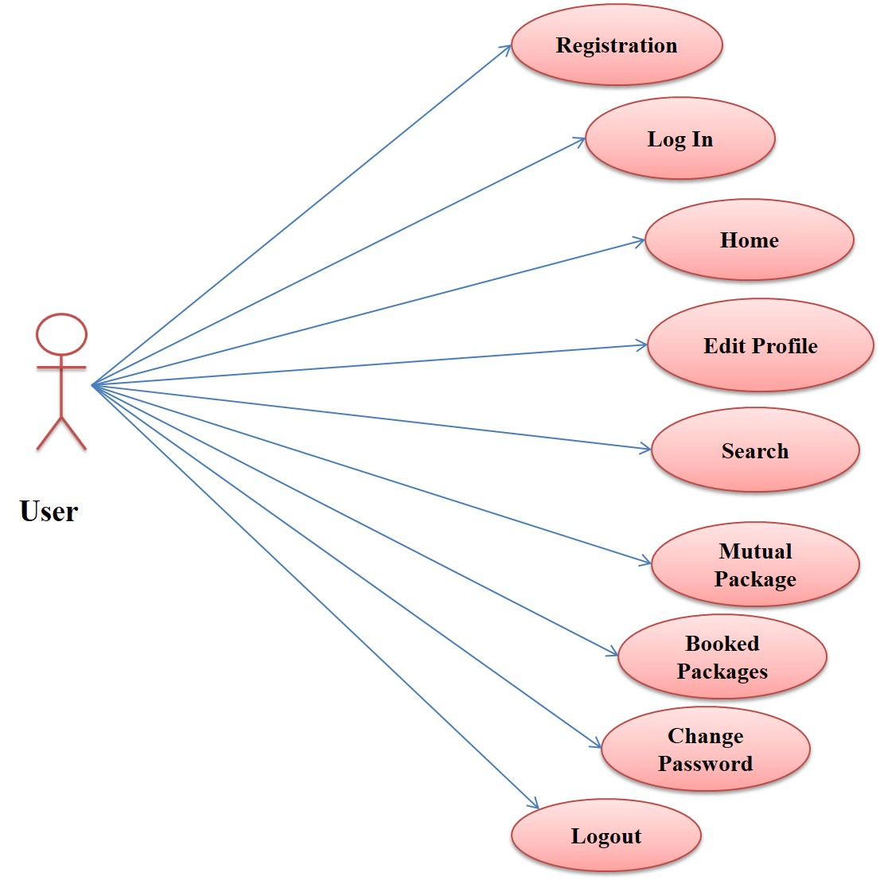

**Figure3.2: Use case Diagram of User**

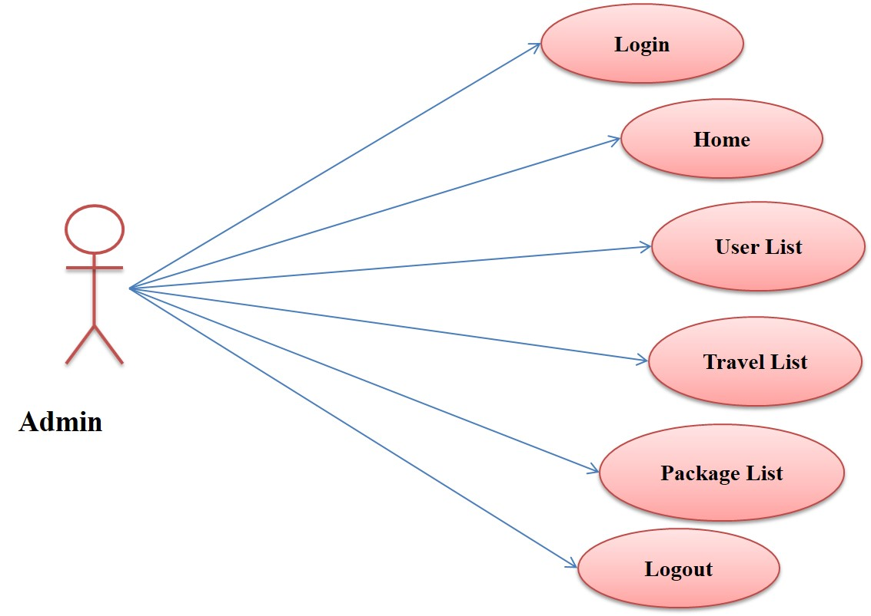

**Figure3.3: Use case Diagram of Admin**



**Figure3.4: Use case Diagram of Travel Admin**

**3.9 Proposed Algorithm Approach**

**Tourist Area Collaborative Relation Topic(TACRT)**

In this section, we describe our approach that shows how a user can learn whether there are at least k users including himself/herself in a given query area, where k is a value chosen by the user. The query area initially corresponds to user's current cell and if the user finds out that there are fewer than k users in this cell, he/she can enlarge the query area and re-execute the protocol for the enlarged area. This process can be repeated multiple times.

The step of algorithm of collaborative approach is described as followers:

Step 1: The user must registered into the system User set {u1, u2……….un}.

Step 2: Each user record saves into the system with security.

Step 3: The request comes from various nodes with their ip addresses. The server sends the notification to each user set {Um1…….Umn}.

Step 4: The system records interest of each user according to searching pattern. User set {u1……………... un}

U Interest Set {I1……… In}

Step 5: Package recommendation phase activated according to mutual user account Package Set { p1…………. Pn }

If( u1 = = I1)

Then u1= p1

Step 6: The step 5 repeat every time for each and every new and existing user.

Where,

u1……un indicates user list,

Um1…Umn indicates registration confirmation message

I1……In indicates user interested set

p1……pn indicates packages set

**Chapter 4**

**IMPLEMENTATION**

Implementation is the stage of the project when the theoretical design is turned out into a working system. Thus, it can be considered to be the most critical stage in archiving a successful new system and in giving the user, confidence that the new system will work and be effective. The implantation stage involves careful planning, investigation of the existing system and its constraints on implantation, designing of methods to achieve changeover methods.

Implementation is the process of converting a new system design into operation. It is the phase that focuses on user training, site preparation and file conversion for installing a candidate system. The important factor that should be consider here is that the conversion should not disrupt the following of the organization.

Implementation is the process of having system personnel check out and put new equipment into user, install the new application, and construct any files of data needed to use it. The world implementation means changing the older system to new system to new system that is adapting new features. To implement the system. The system is found to be user friendly to proceed with each and every action associated with the development of the software.

Implementation is the stage of the project when the theoretical design is turned out into a working system. Thus, it can be considered to be the most critical stage in achieving a successful new system and in giving the user, confidence that new system will work and be effective. The implementation stage involves careful planning, investigation of the existing system and it’s constraints on the implementation, designing of methods to achieve change over and evaluation of changeover methods. For developing any project, some type of designing strategy must be used. Then only the project will be developed in the required time and in efficient way.

The proposed model designed Travel-Package Recommendation Model based on Collaborative Approach In the proposed location recommender system, the user’s interaction is done through the user interface module. Then, the user requests are forwarded to the ratings prediction module. The execution as shown in figure.

**4.1 Implemented The Given following STEP**:

1. **Home Page**

This screen shot show the main home page of the project, Including the two main module

1) Registration 2) Login

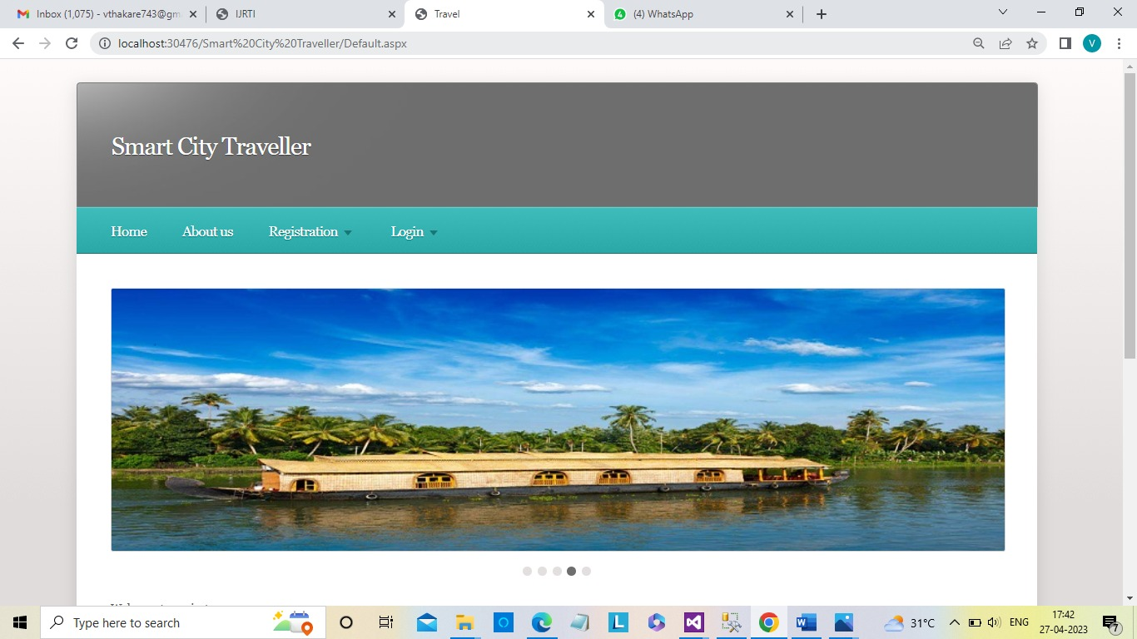

**figure4.1.1: Home Page of System**

The proposed model designed Travel-Package Recommendation Model based on Collaborative Approach In the proposed location recommender system, the user’s interaction is done through the user interface module. Then, the user requests are forwarded to the ratings prediction module. The results as shown in figure. Figure shows the registration form for users.

**2.User Registration Page**

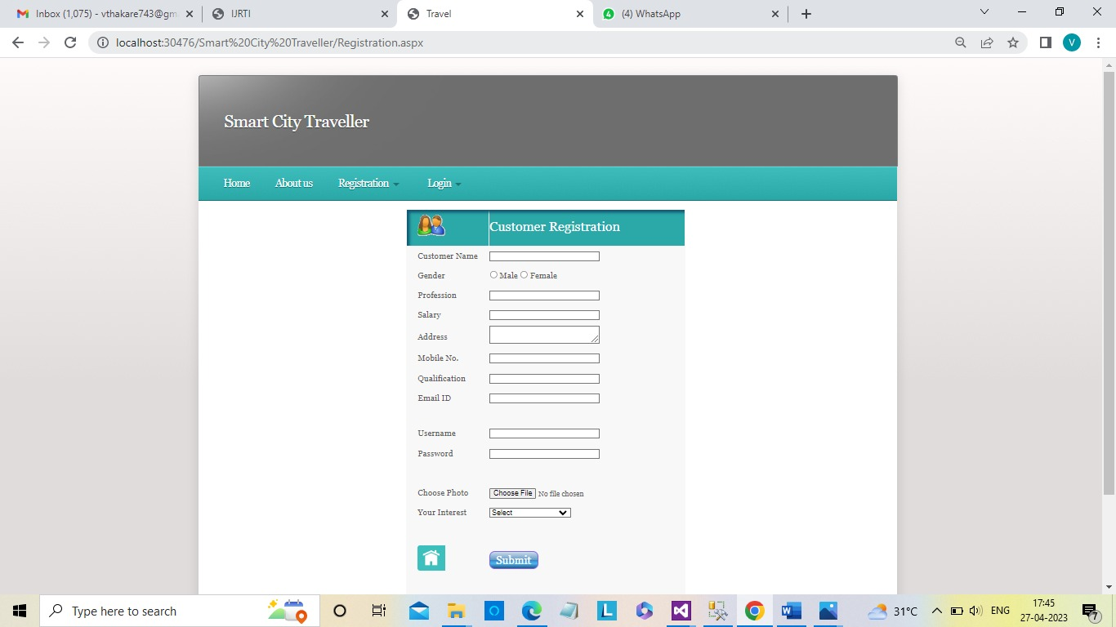

**Fig 4.1.2: Registration Form of System**

After successfully login of users. Figure shows the user model as shown in following. In user model shows the recommended track package.

**3.User Booked**

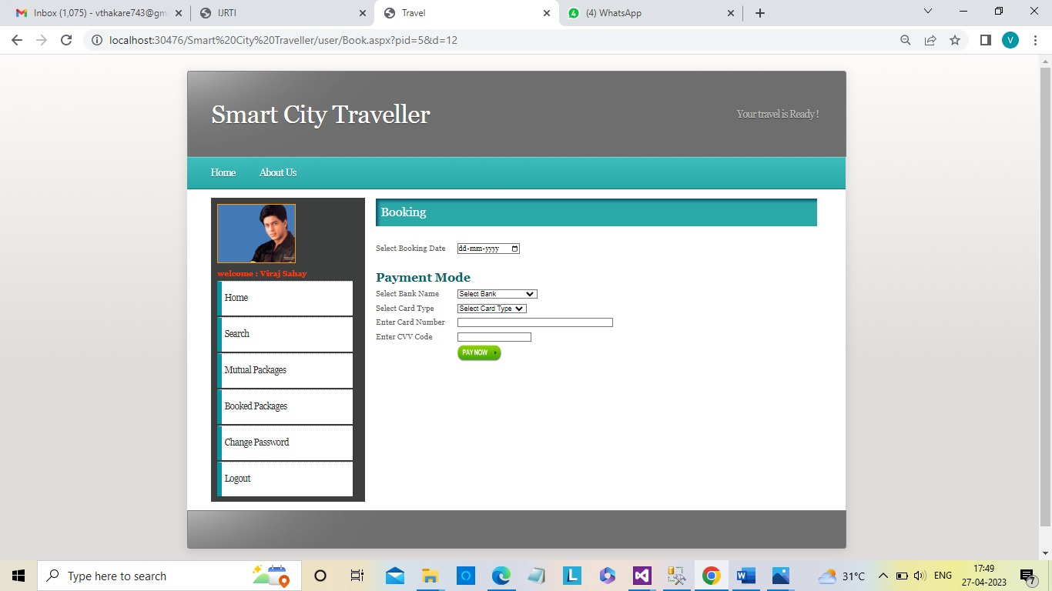

**Fig 4.1.3: Payment Gateway of System**

In the graph shows in figure 5 the x axis indicates the number of user files in database. The y axis indicated the total computational time in ms to perform recommendation using Tartan this above table execution time is calculated this can be calculated with the help of the one query

i.e SET STATISTICS TIME ON

GO

Insert into Registration (id, name, email, mobile, username, pwd-txt, photo, pwd) values(@id,@name,@email,@mobile,@username,@pwd_txt,@photo,@pwd)

GO

SET STATISTICS TIME Off

This execution time may vary it’s depend on the system configuration

**4).Travel Admin Registration.**

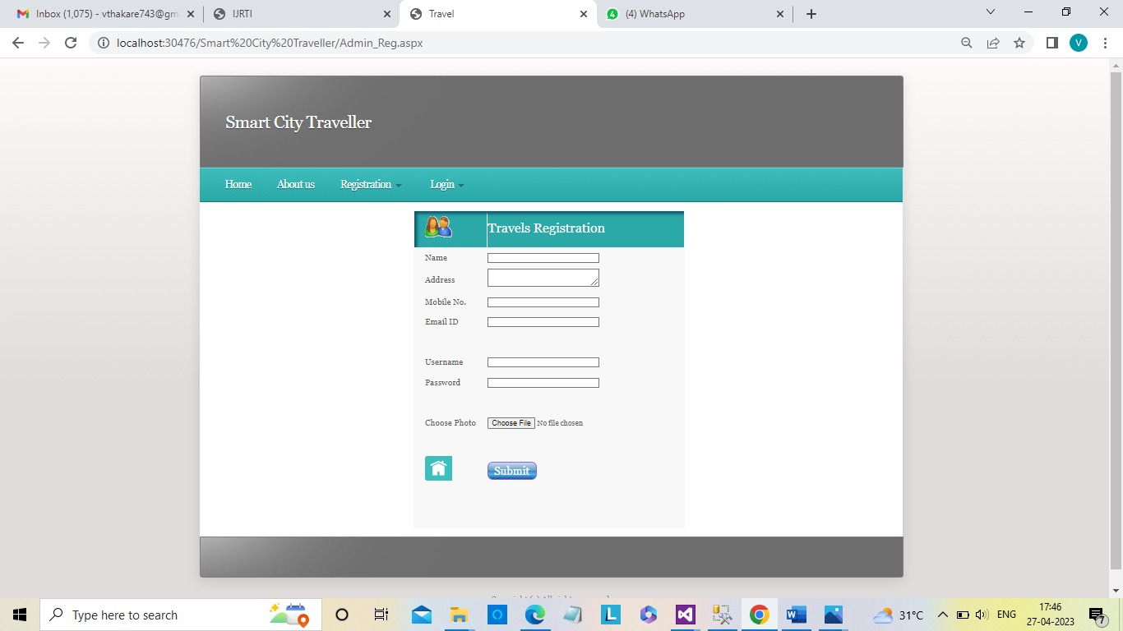

**Figure 4.1.4: Travel Admin Registration of System**

**5)Travel Admin Login**

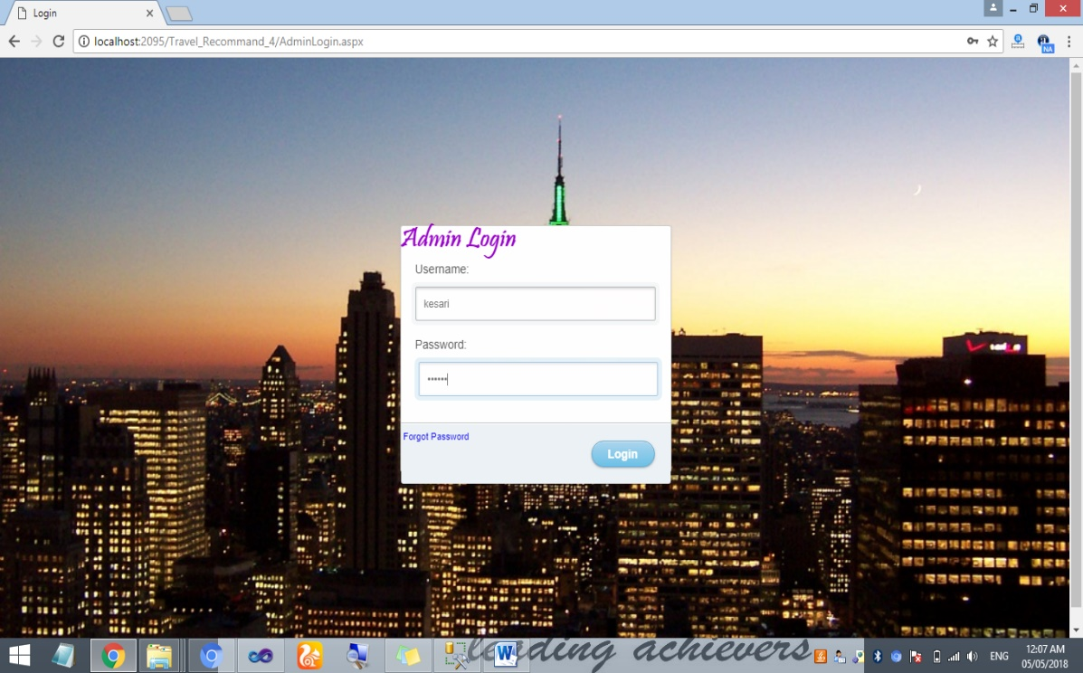**Figure4.1.5 Travel Login Admin Page**

**6)Show Packages List**

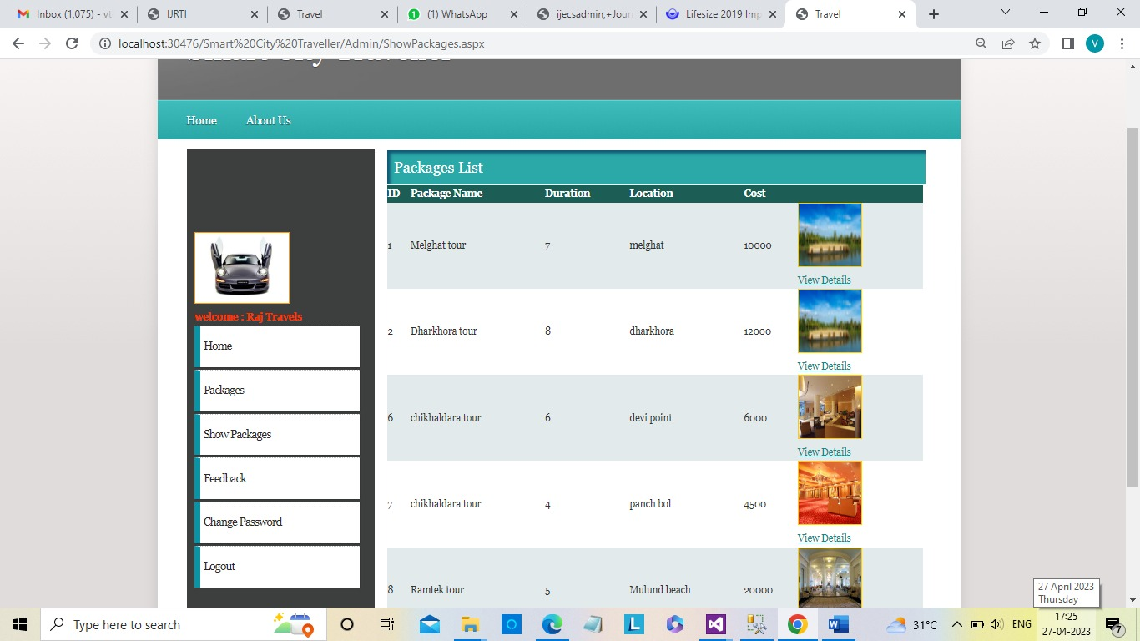

**Figure 4.1.6 Show Packages list of System**

**7)Edit Package**

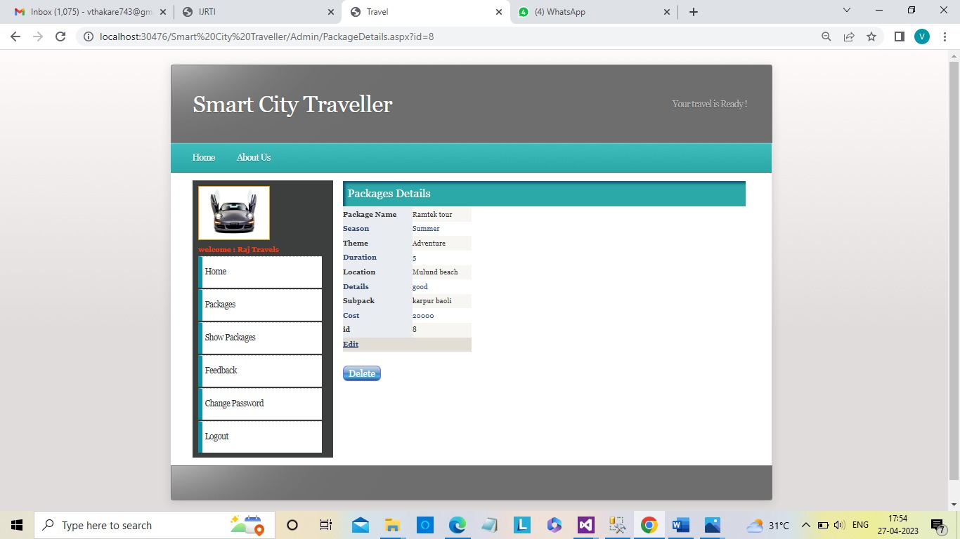

**Figure 4.1.7 Edit Packages Module of System**

**8) Show Feedback List**

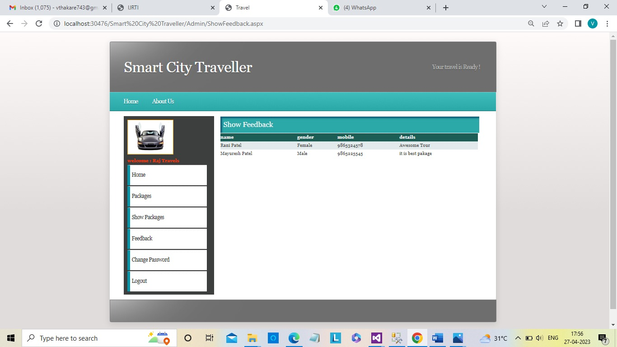

**Figure 4.1.8 Show Feedback list of System**

**9) Change Travel Admin Password**

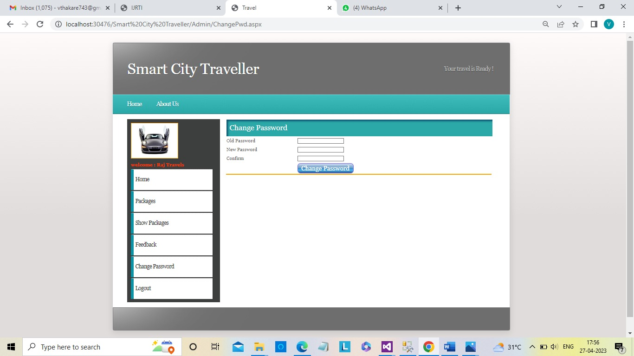

**Figure 4.1.9: Change Travel Admin Password**

**10) User Rating Page OF Data Base**

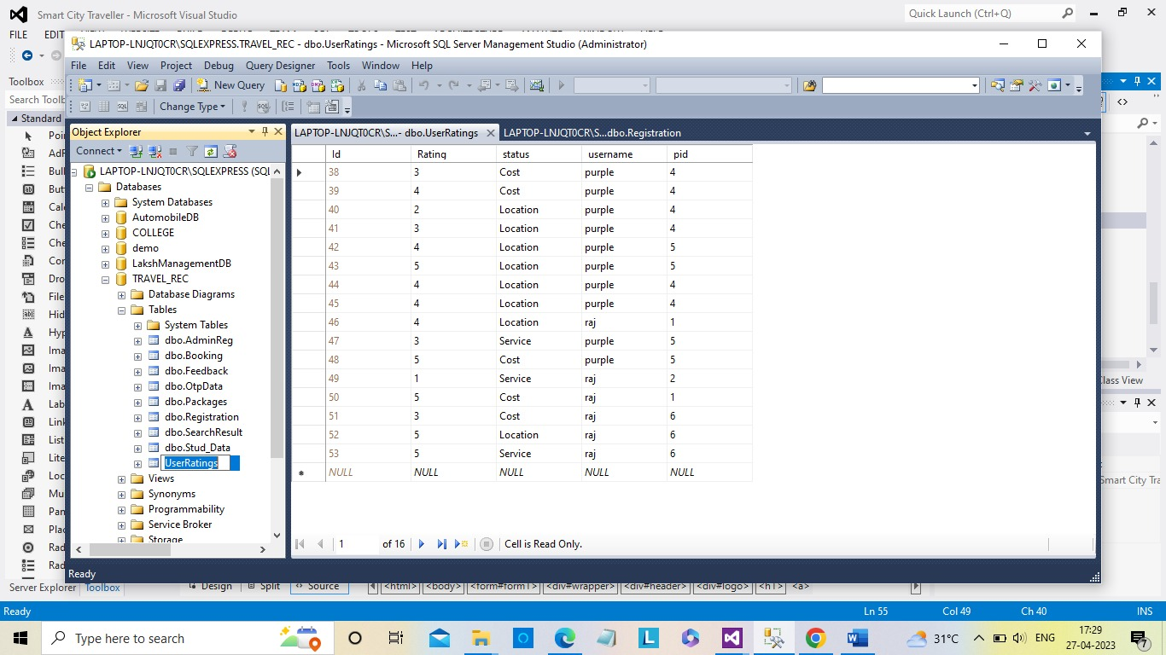

**Figure 4.1.6 User Rating Page Database of System**

**11)User Registration Page of Data Base**

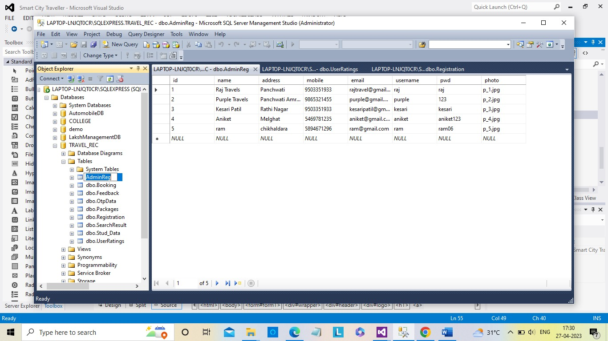

**Figure 4.1.6 User Data Registration page of System**

**Coding Pages**

**Default page:**

<%@ Page Language="C#" AutoEventWireup="true" CodeFile="Default.aspx.cs" Inherits="_Default" %>

<!DOCTYPE html PUBLIC "-//W3C//DTD XHTML 1.0 Strict//EN" "http://www.w3.org/TR/xhtml1/DTD/xhtml1-strict.dtd">

<html xmlns="http://www.w3.org/1999/xhtml">

<head>

<script type="text/javascript">

function DisableBack() {

window.history.forward();

}

DisableBack();

window.onload = DisableBack;

window.onpageshow = function (evt) {

if (evt.persisted) DisableBack();

}

window.onunload = function () { void (0); }

</script>

<meta name="description" content="" />

<meta name="keywords" content="" />

<title>Travel</title>

<meta http-equiv="content-type" content="text/html; charset=utf-8" />

<link rel="stylesheet" type="text/css" href="style.css" />

<link rel="stylesheet" type="text/css" href="css/hover.css" />

<script type="text/javascript" src="jquery-1.7.1.min.js"></script>

<script type="text/javascript" src="jquery.dropotron-1.0.js"></script>

<script type="text/javascript" src="jquery.slidertron-1.1.js"></script>

<script type="text/javascript">

$(function () {

$('#menu > ul').dropotron({

mode: 'fade',

globalOffsetY: 11,

offsetY: -15

});

$('#slider').slidertron({

viewerSelector: '.viewer',

indicatorSelector: '.indicator span',

reelSelector: '.reel',

slidesSelector: '.slide',

speed: 'slow',

advanceDelay: 4000

});

});

</script>

</head>

<body>

<form id="form1" runat="server">

<div id="wrapper">

<div id="header">

<div id="logo">

<h3><a href="#" style="font-size: xx-large">Smart City Traveller</a></h3>

</div>

<div id="slogan">

<h2>

</h2>

</div>

</div>

<div id="menu">

<ul>

<li>

<a href="Default.aspx">Home</a>

</li>

<li><a href="AboutUs.aspx">About us</a></li>

<li>

<span class="opener">Registration<b></b></span>

<ul>

<li><a href="Registration.aspx">User</a></li>

<li><a href="Admin_Reg.aspx">Travel Admin</a></li>

</ul>

</li>

<li>

<span class="opener">Login<b></b></span>

<ul>

<li><a href="Login.aspx">User</a></li>

<li><a href="AdminLogin.aspx">Travel Admin</a></li>

<li><a href="MainAdmin.aspx">Main Admin</a></li>

</ul>

</li>

</ul>

<br class="clearfix" />

</div>

<div id="slider">

<div class="viewer">

<div class="reel">

<div class="slide">

<img src="images/slide01.jpg" alt="" />

</div>

<div class="slide">

<img src="images/slide02.jpg" alt="" />

</div>

<div class="slide">

<img src="images/slide03.jpg" alt="" />

</div>

<div class="slide">

<img src="images/slide04.jpg" alt="" />

</div>

<div class="slide">

<img src="images/slide05.jpg" alt="" />

</div>

</div>

</div>

<div class="indicator">

<span>1</span>

<span>2</span>

<span>3</span>

<span>4</span>

<span>5</span>

</div>

</div>

<div id="page">

<div id="mid">

Welcome to project

</div>

</div>

<div id="page-bottom">

<br class="clearfix" />

</div>

</div>

<div id="footer">

Copyright (c) All rights reserved.

</div>

</form>

</body>

</html>

**Master Page :**

<%@ Master Language="C#" AutoEventWireup="true" CodeFile="MasterPage.master.cs" Inherits="MasterPage" %>

<!DOCTYPE html PUBLIC "-//W3C//DTD XHTML 1.0 Strict//EN" "http://www.w3.org/TR/xhtml1/DTD/xhtml1-strict.dtd">

<html xmlns="http://www.w3.org/1999/xhtml">

<head>

<script type="text/javascript">

function DisableBack() {

window.history.forward();

}

DisableBack();

window.onload = DisableBack;

window.onpageshow = function (evt) {

if (evt.persisted) DisableBack();

}

window.onunload = function () { void (0); }

</script>

<meta name="description" content="" />

<meta name="keywords" content="" />

<title>Travel</title>

<meta http-equiv="content-type" content="text/html; charset=utf-8" />

<link rel="stylesheet" type="text/css" href="style.css" />

<link rel="stylesheet" type="text/css" href="css/hover.css" />

<script type="text/javascript" src="jquery-1.7.1.min.js"></script>

<script type="text/javascript" src="jquery.dropotron-1.0.js"></script>

<script type="text/javascript" src="jquery.slidertron-1.1.js"></script>

<script type="text/javascript">

$(function () {

$('#menu > ul').dropotron({

mode: 'fade',

globalOffsetY: 11,

offsetY: -15

});

// $('#slider').slidertron({

// viewerSelector: '.viewer',

// indicatorSelector: '.indicator span',

// reelSelector: '.reel',

// slidesSelector: '.slide',

// speed: 'slow',

// advanceDelay: 4000

// });

});

</script>

</head>

<body>

<form id="form1" runat="server">

<div id="wrapper">

<div id="header">

<div id="logo">

<h4><a href="#" style="font-size: xx-large">Smart City Traveller</a></h4>

</div>

<div id="slogan">

<h2>

</h2>

</div>

</div>

<div id="menu">

<ul>

<li>

<a href="Default.aspx">Home</a>

</li>

<li><a href="AboutUs.aspx">About us</a></li>

<li>

<span class="opener">Registration<b></b></span>

<ul>

<li><a href="Registration.aspx">User</a></li>

<li><a href="Admin_Reg.aspx">Travel Admin</a></li>

</ul>

</li>

<li>

<span class="opener">Login<b></b></span>

<ul>

<li><a href="Login.aspx">User</a></li>

<li><a href="AdminLogin.aspx">Travel Admin</a></li>

<li><a href="MainAdmin.aspx">Main Admin</a></li>

</ul>

</li>

</ul>

<br class="clearfix" />

</div>

<%-- <div id="slider">

<div class="viewer">

<div class="reel">

<div class="slide">

<img src="images/slide01.jpg" alt="" />

</div>

<div class="slide">

<img src="images/slide02.jpg" alt="" />

</div>

<div class="slide">

<img src="images/slide03.jpg" alt="" />

</div>

<div class="slide">

<img src="images/slide04.jpg" alt="" />

</div>

<div class="slide">

<img src="images/slide05.jpg" alt="" />

</div>

</div>

</div>

<div class="indicator">

<span>1</span>

<span>2</span>

<span>3</span>

<span>4</span>

<span>5</span>

</div>

</div>--%>

<div id="page">

<div id="mid">

<asp:ContentPlaceHolder ID="ContentPlaceHolder1" runat="server">

</asp:ContentPlaceHolder>

</div>

</div>

<div id="page-bottom">

<br class="clearfix" />

</div>

</div>

<div id="footer">

Copyright (c) All rights reserved.

</div>

</form>

</body>

</html>

**User Registration:**

<%@ Page Title="" Language="C#" MasterPageFile="~/MasterPage.master" AutoEventWireup="true" CodeFile="Registration.aspx.cs" Inherits="Registration" %>

<asp:Content ID="Content1" ContentPlaceHolderID="ContentPlaceHolder1" Runat="Server">

<center>

<table bgcolor="White" class="tbl-style">

<tr class="tbl-header">

<td align="left" class="style4">

<asp:Image ID="Image4" runat="server" ImageUrl="~/web_img/registration.png"

Width="50px" />

</td>

<td align="left" >

<asp:Label ID="Label3" runat="server" Font-Size="X-Large" ForeColor="White"

Text="Customer Registration"></asp:Label>

</td>

</tr>

<tr>

<td align="left" class="style4">

Customer

Name</td>

<td align="left">

<asp:TextBox ID="txtname" runat="server" Width="200px"></asp:TextBox>

<asp:RequiredFieldValidator ID="RequiredFieldValidator1" runat="server"

ControlToValidate="txtname" Display="Dynamic"

ErrorMessage="RequiredFieldValidator" ForeColor="#FF3300"

SetFocusOnError="True">Fill Up The Field</asp:RequiredFieldValidator>

<asp:RegularExpressionValidator ID="RegularExpressionValidator3" runat="server"

ControlToValidate="txtname" ErrorMessage="RegularExpressionValidator"

ForeColor="#FF3300" ValidationExpression="[a-zA-Z ]*$">Must be in Alphabets</asp:RegularExpressionValidator>

</td>

</tr>

<tr>

<td align="left" class="style4">

Gender</td>

<td align="left">

<asp:RadioButtonList ID="rbgender" runat="server"

RepeatDirection="Horizontal">

<asp:ListItem>Male</asp:ListItem>

<asp:ListItem>Female</asp:ListItem>

</asp:RadioButtonList>

</td>

</tr>

<tr>

<td align="left" class="style4">

Profession</td>

<td align="left">

<asp:TextBox ID="txtocc" runat="server" Width="200px"></asp:TextBox>

<asp:RequiredFieldValidator ID="RequiredFieldValidator3" runat="server"

ControlToValidate="txtocc" Display="Dynamic"

ErrorMessage="RequiredFieldValidator" ForeColor="#FF3300"

SetFocusOnError="True">Fill Up The Field</asp:RequiredFieldValidator>

<asp:RegularExpressionValidator ID="RegularExpressionValidator4" runat="server"

ControlToValidate="txtocc" ErrorMessage="RegularExpressionValidator"

ForeColor="#FF3300" ValidationExpression="[a-zA-Z ]*$">Must be in Alphabets</asp:RegularExpressionValidator>

</td>

</tr>

<tr>

<td align="left" class="style4">

Salary</td>

<td align="left">

<asp:TextBox ID="txtsalary" runat="server" Width="200px" MaxLength="10"></asp:TextBox>

</td>

</tr>

<tr>

<td align="left" class="style4">

Address</td>

<td align="left">

<asp:TextBox ID="txtadd" runat="server" TextMode="MultiLine" Width="200px"></asp:TextBox>

</td>

</tr>

<tr>

<td align="left" class="style4">

Mobile No.</td>

<td align="left">

<asp:TextBox ID="txtmob" runat="server" Width="200px" MaxLength="10"></asp:TextBox>

<asp:RegularExpressionValidator ID="RegularExpressionValidator2" runat="server"

ControlToValidate="txtmob" Display="Dynamic"

ErrorMessage="RegularExpressionValidator" ForeColor="#FF3300"

ValidationExpression="\d{10}">Must be proper format</asp:RegularExpressionValidator>

</td>

</tr>

<tr>

<td align="left" class="style4">

Qualification</td>

<td align="left">

<asp:TextBox ID="txtqua" runat="server" Width="200px"></asp:TextBox>

</td>

</tr>

<tr>

<td align="left" class="style4">

Email ID</td>

<td align="left">

<asp:TextBox ID="txtemail" runat="server" Width="200px"></asp:TextBox>

<asp:RequiredFieldValidator ID="RequiredFieldValidator2" runat="server"

ControlToValidate="txtemail" Display="Dynamic"

ErrorMessage="RequiredFieldValidator" ForeColor="#FF3300"

SetFocusOnError="True">Fill Up The Field</asp:RequiredFieldValidator>

<asp:RegularExpressionValidator ID="RegularExpressionValidator1" runat="server"

ControlToValidate="txtemail" Display="Dynamic"

ErrorMessage="RegularExpressionValidator" ForeColor="#FF3300"

ValidationExpression="\w+([-+.']\w+)*@\w+([-.]\w+)*\.\w+([-.]\w+)*">Must be in Proper Format</asp:RegularExpressionValidator>

</td>

</tr>

<tr>

<td align="left" class="style4">

</td>

<td align="left" class="style1">

&nbsp;</td>

</tr>

<tr>

<td align="left" class="style4" style="height: 28px">

Username</td>

<td align="left" class="style1" style="height: 28px">

<asp:TextBox ID="txtuser" runat="server" Width="200px"></asp:TextBox>

</td>

</tr>

<tr>

<td align="left" class="style4">

Password</td>

<td align="left" class="style1">

<asp:TextBox ID="txtpwd" runat="server" Width="200px" TextMode="Password"></asp:TextBox>

</td>

</tr>

<tr>

<td align="left" class="style4">

&nbsp;</td>

<td align="left" class="style1">

&nbsp;</td>

</tr>

<tr>

<td align="left" class="style4">

Choose Photo</td>

<td align="left" class="style1">

<asp:FileUpload ID="FileUpload1" runat="server" />

</td>

</tr>

<tr>

<td align="left" class="style4">

Your Interest</td>

<td align="left" class="style1">

<asp:DropDownList ID="ddlTheme" runat="server" Width="150px">

<asp:ListItem>Select</asp:ListItem>

<asp:ListItem>Historical</asp:ListItem>

<asp:ListItem>Jungle Safari</asp:ListItem>

<asp:ListItem>Adventure</asp:ListItem>

<asp:ListItem>Others</asp:ListItem>

</asp:DropDownList>

</td>

</tr>

<tr>

<td align="left" class="style4">

&nbsp;</td>

<td align="left" class="style1">

&nbsp;</td>

</tr>

<tr>

<td align="left" class="style4">

<a href="default.aspx">

<asp:Image ID="Image5" runat="server" ImageUrl="~/web_img/home.png"

Width="50px" />

</a>

</td>

<td align="left" class="style1">

<asp:Button ID="Button1" runat="server" onclick="Button1_Click" Text="Submit" class="btn-style hvr-shrink" />

</td>

</tr>

<tr>

<td align="left" class="style4">

&nbsp;</td>

<td align="left" class="style1">

<asp:HiddenField ID="hfid" runat="server" />

</td>

</tr>

<tr>

<td align="left" class="style4">

&nbsp;</td>

<td align="left" class="style1">

<asp:Label ID="lblmsg" runat="server" Font-Bold="True" ForeColor="#339933"></asp:Label>

<asp:SqlDataSource ID="SqlDataSource1" runat="server"

ConnectionString="<%$ ConnectionStrings:TRAVEL_RECConnectionString %>"

DeleteCommand="DELETE FROM [Registration] WHERE [id] = @id"

InsertCommand="INSERT INTO [Registration] ([id], [name], [gender], [occupation], [address], [mobile], [qua], [email], [username], [pwd], [photo]) VALUES (@id, @name, @gender, @occupation, @address, @mobile, @qua, @email, @username, @pwd, @photo)"

SelectCommand="SELECT * FROM [Registration]"

UpdateCommand="UPDATE [Registration] SET [name] = @name, [gender] = @gender, [occupation] = @occupation, [address] = @address, [mobile] = @mobile, [qua] = @qua, [email] = @email, [username] = @username, [pwd] = @pwd, [photo] = @photo WHERE [id] = @id">

<DeleteParameters>

<asp:Parameter Name="id" Type="Int32" />

</DeleteParameters>

<InsertParameters>

<asp:Parameter Name="id" Type="Int32" />

<asp:Parameter Name="name" Type="String" />

<asp:Parameter Name="gender" Type="String" />

<asp:Parameter Name="occupation" Type="String" />

<asp:Parameter Name="address" Type="String" />

<asp:Parameter Name="mobile" Type="String" />

<asp:Parameter Name="qua" Type="String" />

<asp:Parameter Name="email" Type="String" />

<asp:Parameter Name="username" Type="String" />

<asp:Parameter Name="pwd" Type="String" />

<asp:Parameter Name="photo" Type="String" />

</InsertParameters>

<UpdateParameters>

<asp:Parameter Name="name" Type="String" />

<asp:Parameter Name="gender" Type="String" />

<asp:Parameter Name="occupation" Type="String" />

<asp:Parameter Name="address" Type="String" />

<asp:Parameter Name="mobile" Type="String" />

<asp:Parameter Name="qua" Type="String" />

<asp:Parameter Name="email" Type="String" />

<asp:Parameter Name="username" Type="String" />

<asp:Parameter Name="pwd" Type="String" />

<asp:Parameter Name="photo" Type="String" />

<asp:Parameter Name="id" Type="Int32" />

</UpdateParameters>

</asp:SqlDataSource>

</td>

</tr>

</table>

</center>

</asp:Content>

**User Booking:**

<%@ Page Title="" Language="C#" MasterPageFile="~/user/UserMasterPage.master" AutoEventWireup="true" CodeFile="Book.aspx.cs" Inherits="user_Book" %>

<asp:Content ID="Content1" ContentPlaceHolderID="ContentPlaceHolder1" Runat="Server">

<table style="width:100%;">

<tr class="tbl-header">

<td colspan="2" class="inner-head">

<asp:Label ID="Label2" runat="server" Text="Booking "></asp:Label>

</td>

</tr>

<tr>

<td style="width: 157px">

&nbsp;</td>

<td>

&nbsp;</td>

</tr>

<tr>

<td style="width: 157px">

Select Booking Date</td>

<td>

<asp:TextBox ID="txtBookDate" runat="server" TextMode="Date"></asp:TextBox>

<asp:RequiredFieldValidator ID="RequiredFieldValidator3" runat="server"

ControlToValidate="txtBookDate" Display="Dynamic"

ErrorMessage="RequiredFieldValidator" ForeColor="#FF3300"

SetFocusOnError="True">Please Select Booking Date</asp:RequiredFieldValidator>

</td>

</tr>

<tr>

<td style="width: 157px">

&nbsp;</td>

<td>

&nbsp;</td>

</tr>

<tr>

<td colspan="2">

<asp:Label ID="Label1" runat="server" Font-Bold="True" Font-Size="X-Large"

ForeColor="#006666" Text="Payment Mode"></asp:Label>

</td>

</tr>

<tr>

<td style="width: 157px">

Select Bank Name</td>

<td>

<asp:DropDownList ID="DropDownList1" runat="server">

<asp:ListItem>Select Bank</asp:ListItem>

<asp:ListItem>State Bank of India</asp:ListItem>

<asp:ListItem>Bank of India</asp:ListItem>

<asp:ListItem>Bank of Maharashtra</asp:ListItem>

<asp:ListItem>Bank of Badoda</asp:ListItem>

<asp:ListItem>Axis Bank</asp:ListItem>

</asp:DropDownList>

</td>

</tr>

<tr>

<td style="width: 157px">

Select Card Type</td>

<td>

<asp:DropDownList ID="DropDownList2" runat="server">

<asp:ListItem>Select Card Type</asp:ListItem>

<asp:ListItem>Master card</asp:ListItem>

<asp:ListItem>Mastrov</asp:ListItem>

<asp:ListItem>Visa</asp:ListItem>

</asp:DropDownList>

</td>

</tr>

<tr>

<td style="width: 157px">

Enter Card Number</td>

<td>

<asp:TextBox ID="txtcardno" runat="server" Width="300px" MaxLength="14"></asp:TextBox>

<asp:RequiredFieldValidator ID="RequiredFieldValidator1" runat="server"

ControlToValidate="txtcardno" Display="Dynamic"

ErrorMessage="RequiredFieldValidator" ForeColor="#FF3300"

SetFocusOnError="True">Enter the card number</asp:RequiredFieldValidator>

<asp:RegularExpressionValidator ID="RegularExpressionValidator2" runat="server"

ControlToValidate="txtcardno" Display="Dynamic"

ErrorMessage="RegularExpressionValidator" ForeColor="#FF3300"

ValidationExpression="\d{14}">Must be 14 DigitNumber</asp:RegularExpressionValidator>

</td>

</tr>

<tr>

<td style="width: 157px">

Enter CVV Code</td>

<td>

<asp:TextBox ID="txtcvv" runat="server" Width="141px" TextMode="Password"></asp:TextBox>

<asp:RequiredFieldValidator ID="RequiredFieldValidator2" runat="server"

ControlToValidate="txtcvv" Display="Dynamic"

ErrorMessage="RequiredFieldValidator" ForeColor="#FF3300"

SetFocusOnError="True">Enter the CVV Code</asp:RequiredFieldValidator>

</td>

</tr>

<tr>

<td style="width: 157px">

&nbsp;</td>

<td>

<asp:ImageButton ID="btnSubmit" runat="server"

ImageUrl="~/web_img/pay_now.png" onclick="btnSubmit_Click" Height="33px"

Width="91px" />

<asp:SqlDataSource ID="SqlDataSource1" runat="server"

ConnectionString="<%$ ConnectionStrings:TRAVEL_RECConnectionString %>"

DeleteCommand="DELETE FROM [Booking] WHERE [id] = @id"

InsertCommand="INSERT INTO [Booking] ([username], [pid]) VALUES (@username, @pid)"

SelectCommand="SELECT * FROM [Booking]"

UpdateCommand="UPDATE [Booking] SET [username] = @username, [pid] = @pid WHERE [id] = @id">

<DeleteParameters>

<asp:Parameter Name="id" Type="Int32" />

</DeleteParameters>

<InsertParameters>

<asp:SessionParameter Name="username" SessionField="userid" Type="String" />

<asp:QueryStringParameter Name="pid" QueryStringField="pid" Type="Int32" />

</InsertParameters>

<UpdateParameters>

<asp:Parameter Name="username" Type="String" />

<asp:Parameter Name="pid" Type="Int32" />

<asp:Parameter Name="id" Type="Int32" />

</UpdateParameters>

</asp:SqlDataSource>

</td>

</tr>

<tr>

<td style="width: 157px">

&nbsp;</td>

<td>

&nbsp;</td>

</tr>

<tr>

<td style="width: 157px">

&nbsp;</td>

<td>

&nbsp;</td>

</tr>

</table>

</asp:Content>

**Travel Admin Masterpage:**

<%@ Master Language="C#" AutoEventWireup="true" CodeFile="AdminMasterPage.master.cs" Inherits="Admin_AdminMasterPage" %>

<!DOCTYPE html PUBLIC "-//W3C//DTD XHTML 1.0 Strict//EN" "http://www.w3.org/TR/xhtml1/DTD/xhtml1-strict.dtd">

<html xmlns="http://www.w3.org/1999/xhtml">

<head id="Head1" runat="server">

<script type="text/javascript">

function DisableBack() {

window.history.forward();

}

DisableBack();

window.onload = DisableBack;

window.onpageshow = function (evt) {

if (evt.persisted) DisableBack();

}

window.onunload = function () { void (0); }

</script>

<meta name="description" content="" />

<meta name="keywords" content="" />

<title>Travel</title>

<meta http-equiv="content-type" content="text/html; charset=utf-8" />

<link rel="stylesheet" type="text/css" href="../style.css" />

<link rel="stylesheet" type="text/css" href="../css/hover.css" />

<link rel="stylesheet" type="text/css" href="../css/side-menu.css" />

<script type="text/javascript" src="../jquery-1.7.1.min.js"></script>

<script type="text/javascript" src="../jquery.dropotron-1.0.js"></script>

<script type="text/javascript" src="../jquery.slidertron-1.1.js"></script>

<script type="text/javascript">

$(function () {

$('#menu > ul').dropotron({

mode: 'fade',

globalOffsetY: 11,

offsetY: -15

});

// $('#slider').slidertron({

// viewerSelector: '.viewer',

// indicatorSelector: '.indicator span',

// reelSelector: '.reel',

// slidesSelector: '.slide',

// speed: 'slow',

// advanceDelay: 4000

// });

});

</script>

</head>

<body>

<form id="form1" runat="server">

<div id="wrapper">

<div id="header">

<div id="logo">

<h1><a href="#">Smart City Traveller</a></h1>

</div>

<div id="slogan">

<h2>Your travel is Ready !</h2>

</div>

</div>

<div id="menu">

<ul>

<li>

<a href="Default.aspx">Home</a>

</li>

<li><a href="#">About Us</a></li>

</ul>

<br class="clearfix" />

</div>

<div id="page">

<div id="mid">

<table style="width:100%;">

<tr>

<td width="300px" class="left-sidebar">

<div class="leftpane">

<asp:Image ID="Image1" runat="server" Width="150px" BorderColor="#FF9900"

BorderStyle="Solid" BorderWidth="1px" />

<br />

<asp:Label ID="lbluser" runat="server" ForeColor="#FF3300" Font-Bold="True"></asp:Label>

<br />

<%--<asp:Menu ID="Menu1" runat="server" BackColor="#B5C7DE"

DynamicHorizontalOffset="2" Font-Names="Verdana" Font-Size="Small"

ForeColor="#284E98" StaticSubMenuIndent="10px" Width="150px">

<DynamicHoverStyle BackColor="#284E98" ForeColor="White" />

<DynamicMenuItemStyle HorizontalPadding="5px" VerticalPadding="2px" />

<DynamicMenuStyle BackColor="#B5C7DE" />

<DynamicSelectedStyle BackColor="#507CD1" />

<Items>

<asp:MenuItem Text="Home" Value="Home" NavigateUrl="~/Admin/Default.aspx"></asp:MenuItem>

<asp:MenuItem Text="Packages" Value="New Item"

NavigateUrl="~/Admin/Package.aspx"></asp:MenuItem>

<asp:MenuItem NavigateUrl="~/Admin/ShowPackages.aspx" Text="Show Packages"

Value="Show Packages"></asp:MenuItem>

<asp:MenuItem Text="Feedback" Value="Feedback"

NavigateUrl="~/Admin/ShowFeedback.aspx"></asp:MenuItem>

<asp:MenuItem Text="Change Password" Value="New Item"

NavigateUrl="~/Admin/ChangePwd.aspx"></asp:MenuItem>

<asp:MenuItem Text="Logout" Value="Logout" NavigateUrl="~/Admin/Logout.aspx"></asp:MenuItem>

</Items>

<StaticHoverStyle BackColor="#284E98" ForeColor="White" />

<StaticMenuItemStyle HorizontalPadding="5px" VerticalPadding="2px" />

<StaticSelectedStyle BackColor="#507CD1" />

</asp:Menu>--%>

<ul class="ca-menu">

<li>

<a href="Default.aspx">

<div class="ca-content">

<h2 class="ca-main">Home</h2>

</div>

</a>

</li>

<li>

<a href="Package.aspx">

<div class="ca-content">

<h2 class="ca-main">Packages</h2>

</div>

</a>

</li>

<li>

<a href="ShowPackages.aspx">

<div class="ca-content">

<h2 class="ca-main">Show Packages</h2>

</div>

</a>

</li>

<li>

<a href="ShowFeedback.aspx">

<div class="ca-content">

<h2 class="ca-main">Feedback</h2>

</div>

</a>

</li>

<li>

<a href="ChangePwd.aspx">

<div class="ca-content">

<h2 class="ca-main">Change Password</h2>

</div>

</a>

</li>

<li>

<a href="Logout.aspx">

<div class="ca-content">

<h2 class="ca-main">Logout</h2>

</div>

</a>

</li>

</ul>

<asp:SqlDataSource ID="SqlDataGetData" runat="server"

ConnectionString="<%$ ConnectionStrings:TRAVEL_RECConnectionString %>"

SelectCommand="SELECT [name], [photo],[id] FROM [AdminReg] WHERE ([username] = @username)">

<SelectParameters>

<asp:SessionParameter Name="username" SessionField="userid" Type="String" />

</SelectParameters>

</asp:SqlDataSource>

</div>

</td>

<td valign="top">

<div class="rightpane">

<asp:ContentPlaceHolder ID="ContentPlaceHolder1" runat="server">

</asp:ContentPlaceHolder>

</div>

</td>

</tr>

</table>

</div>

</div>

<div id="page-bottom">

<br class="clearfix" />

</div>

</div>

<div id="footer">

Copyright (c) All rights reserved.

</div>

</form>

</body>

</html>

**Travel Admin Registration:**

<%@ Page Title="" Language="C#" MasterPageFile="~/MasterPage.master" AutoEventWireup="true" CodeFile="Admin_Reg.aspx.cs" Inherits="Admin_Reg" %>

<asp:Content ID="Content1" ContentPlaceHolderID="ContentPlaceHolder1" Runat="Server">

<center>

<table bgcolor="White" class="tbl-style">

<tr class="tbl-header">

<td align="left" class="style4">

<asp:Image ID="Image4" runat="server" ImageUrl="~/web_img/registration.png"

Width="50px" />

</td>

<td align="left" >

<asp:Label ID="Label3" runat="server" Font-Size="X-Large" ForeColor="White"

Text="Travels Registration"></asp:Label>

</td>

</tr>

<tr>

<td align="left" class="style4" style="height: 28px">

Name</td>

<td align="left" style="height: 28px">

<asp:TextBox ID="txtname" runat="server" Width="200px"></asp:TextBox>

<asp:RequiredFieldValidator ID="RequiredFieldValidator1" runat="server"

ControlToValidate="txtname" Display="Dynamic"

ErrorMessage="RequiredFieldValidator" ForeColor="#FF3300"

SetFocusOnError="True">Fill Up The Field</asp:RequiredFieldValidator>

<asp:RegularExpressionValidator ID="RegularExpressionValidator3" runat="server"

ControlToValidate="txtname" ErrorMessage="RegularExpressionValidator"

ForeColor="#FF3300" ValidationExpression="[a-zA-Z ]*$">Must be in Alphabets</asp:RegularExpressionValidator>

</td>

</tr>

<tr>

<td align="left" class="style4">

Address</td>

<td align="left">

<asp:TextBox ID="txtadd" runat="server" TextMode="MultiLine" Width="200px"></asp:TextBox>

</td>

</tr>

<tr>

<td align="left" class="style4">

Mobile No.</td>

<td align="left">

<asp:TextBox ID="txtmob" runat="server" Width="200px" MaxLength="10"></asp:TextBox>

<asp:RegularExpressionValidator ID="RegularExpressionValidator2" runat="server"

ControlToValidate="txtmob" Display="Dynamic"

ErrorMessage="RegularExpressionValidator" ForeColor="#FF3300"

ValidationExpression="\d{10}">Must be proper format</asp:RegularExpressionValidator>

</td>

</tr>

<tr>

<td align="left" class="style4">

Email ID</td>

<td align="left">

<asp:TextBox ID="txtemail" runat="server" Width="200px"></asp:TextBox>

<asp:RequiredFieldValidator ID="RequiredFieldValidator2" runat="server"

ControlToValidate="txtemail" Display="Dynamic"

ErrorMessage="RequiredFieldValidator" ForeColor="#FF3300"

SetFocusOnError="True">Fill Up The Field</asp:RequiredFieldValidator>

<asp:RegularExpressionValidator ID="RegularExpressionValidator1" runat="server"

ControlToValidate="txtemail" Display="Dynamic"

ErrorMessage="RegularExpressionValidator" ForeColor="#FF3300"

ValidationExpression="\w+([-+.']\w+)*@\w+([-.]\w+)*\.\w+([-.]\w+)*">Must be in Proper Format</asp:RegularExpressionValidator>

</td>

</tr>

<tr>

<td align="left" class="style4" style="height: 28px">

</td>

<td align="left" class="style1" style="height: 28px">

</td>

</tr>

<tr>

<td align="left" class="style4" style="height: 28px">

Username</td>

<td align="left" class="style1" style="height: 28px">

<asp:TextBox ID="txtuser" runat="server" Width="200px"></asp:TextBox>

</td>

</tr>

<tr>

<td align="left" class="style4">

Password</td>

<td align="left" class="style1">

<asp:TextBox ID="txtpwd" runat="server" Width="200px" TextMode="Password"></asp:TextBox>

</td>

</tr>

<tr>

<td align="left" class="style4" style="height: 28px">

</td>

<td align="left" class="style1" style="height: 28px">

</td>

</tr>

<tr>

<td align="left" class="style4">

Choose Photo</td>

<td align="left" class="style1">

<asp:FileUpload ID="FileUpload1" runat="server" />

</td>

</tr>

<tr>

<td align="left" class="style4">

&nbsp;</td>

<td align="left" class="style1">

&nbsp;</td>

</tr>

<tr>

<td align="left" class="style4">

<a href=Home.aspx>

<asp:Image ID="Image5" runat="server" ImageUrl="~/web_img/home.png"

Width="50px" />

</a>

</td>

<td align="left" class="style1">

<asp:Button ID="Button1" runat="server" onclick="Button1_Click" Text="Submit" class="btn-style hvr-shrink"/>

</td>

</tr>

<tr>

<td align="left" class="style4">

&nbsp;</td>

<td align="left" class="style1">

<asp:HiddenField ID="hfid" runat="server" />

</td>

</tr>

<tr>

<td align="left" class="style4">

&nbsp;</td>

<td align="left" class="style1">

<asp:Label ID="lblmsg" runat="server" Font-Bold="True" ForeColor="#339933"></asp:Label>

</td>

</tr>

</table>

</center>

</asp:Content>

**Chapter 5**

**RESULT ANALYSIS**

The first step in system design is to divide the system into small number of components. Each major component of system is called a subsystem. Each subsystem encompasses aspects of the system that share some common property similar functionality, the same physical location, or execution on the same kind of hardware.

Given packages are stored in another database record so to identify any interest; see the Packages that appear on the screen, which may or may not be matched with our packages. If any rating and comment share matched more than 70% then operator predict that person is only the package booking and we will get the complete details of that person if saved in our database. Thus, using this project, it provides a very friendly environment for both operator and Security purpose to easily identify the Recommended by the end of the customer services and its background database. A subsystem not an object nor a function but a Module of the of system, Data Mining concept and Recommendation System is usefully executed. Operations, events and constraints that are interrelated and that have reasonable well-defined and small interface with other subsystem usually identified by the services it provides. A service is a group of related functions that share some common purpose such as Company.

**Graph Showing time required for Recommendation According to users**

|  |  |
| --- | --- |
| No. of Files in database | Average Response time for result processing (MS) in Project |
| 10 | 5.3 |
| 15 | 5.4 |
| 20 | 6.1 |
| 25 | 6.4 |
|  |  |

**Table 1: Recommendation According to User**

**Graph 1: Analysis process of Graph Recommendation**

In the above graph the x axis indicates the number of user files in database. The y axis indicated the total computational time in MS to perform recommendation using TACRT.

In this above table execution time is calculated this can be calculated with the help of the one query

i.e. SET STATISTICS TIME ON

GO

Insert

Into Registration(id,name,email,mobile,username,pwd_txt,photo,pwd)values(@id,@name,@email,@mobile,@username,@pwd_txt,@photo,@pwd)

GO

SET STATISTICS TIME On. This execution time may vary it’s depend on the system configuration

**Chapter 6**

**CONCLUSION**

This Project explains a recommendation system for personalized travel sequence. This recommendation system considers the user interest with another attribute of users like time, season, and value of travel. Using this social media knowledge not solely mining users purpose of interest however additionally the travel sequence of the purpose of interest with considering alternative attribute of user. There are many alternative forms of strategies, algorithms and technologies that are used for recommendation. However still there are some issues. The planned system provides a more robust resolution for travel package recommendation. In planned technique, a user is in a position to urge packages counseled by the system. This technique traces the profile info and user searches pattern found the interest of the user, and supply the suitable travel package to user. In result analysis shows details exhaustion about travel package recommendation model in graph shows the time required for Recommendation According to users.

**REFERENCES**

[1] Yan-Ying Chen, An-Jung Cheng, and Winston H. Hsu,” Travel Recommendation by Mining People Attributes and Travel Group Types From Community-Contributed Photos”, IEEE TRANSACTIONS ON MULTIMEDIA, VOL. 15, NO. 6, OCTOBER 2013, paper 2,3.

[2] S. Lai et al., “Hybrid Recommendation Models for Binary User Preference Prediction Problem,” Proc. KDD- Cup 2011 Competition,2011.

[3] Yong Ge, Qi Liu1, Hui Xiong, Alexander Tuzhilin, Jian Chen,” Cost-aware Travel Tour Recommendation,” 17th ACM SIGKDD international conference on Knowledge discovery and data mining, August 21 - 24, 2011.

[4] Yu Zheng, Lizhu Zhang, Xing Xie, Wei-Ying Ma,” Mining Interesting Locations and Travel Sequences from GPS Trajectories”, International conference on World Wide Web 2009 | April 2009.

[5] Shuhui Jiang, Xueming Qian, Tao Mei, Yun Fu, “Personalized Travel Sequence Recommendation on Multi-Source Big Social Media”, IEEE TRANSACTIONS ON BIG DATA, VOL. X, NO. X, SEPTEMBER 2016

[6] Logesh Ravi and Subramaniyaswamy Vairavasundaram,” A Collaborative Location Based Travel Recommendation System through Enhanced Rating Prediction for the Group of Users”, Hinda Wi Publishing Corporation Computational Intelligence and Neuroscience Volume 2016,

[7] Ling Xing, Qian Ma, Song Chen,” A Novel Personalized Recommendation Model based on Location Computing”, Chinese Automation Congress (CAC),20-22 Oct. 2017.

[8] Hassan Takagi, James B. D. Joshi, Hassan A. Karimi,” A Collaborative K -anonymity Approach for Location Privacy in Location-Based Services”, 5th International Conference on Collaborative Computing: Networking, Applications and Work sharing 11-14 Nov. 2009.

[9] Jason C. Hung, Victoria Hsu and Martin M. Weng,” A Study for Task based Recommendation System for Travel Navigation”, International Joint Conference on Awareness Science and Technology & Ubi-Media Computing (iCAST 2013 & UMEDIA 2013),2-4 Nov. 2013.

[10] Joseph Coelho, Paromita Nitu, and Praveen Madiraju,” A Personalized Travel Recommendation System Using Social Media Analysis”, IEEE International Congress on Big Data (BigData Congress), 2-7 July 2018.

[11] Q. Liu, Y. Ge, Z. Li, H. Xiong, and E. Chen, “Personalized Travel Package Recommendation,” Proc. IEEE 11th Int’l Conf. Data Mining(ICDM ’11), pp. 407-416, 2011.

[12] Nikos Mamoulis, Huiping Cao, George Kollios, Marios Hadjieleftheriou, Yufei Tao and David W. Cheung,” Mining, Indexing, and Querying Historical Spatiotemporal Data”, nternational conference on Knowledge discovery and data mining, August 22–25, 2004.

[13] Y. Karen, “Factorization Meets the Neighbourhood: A Multifaceted Collaborative Filtering Model,” Proc. 14th ACM SIGKDD Int’l Conf. Knowledge Discovery and Data Mining (SIGKDD ’08), pp. 426-434,2008.

[14] Mayuri D. Aswale, Dr. S. C. Dharmadhikari,” Survey on Recommendation of Personalized paper 2Travel Sequence”, International Journal of Advanced Research in Computer and Communication Engineering, Vol. 6, Issue 1, January 2017

[15] Q. Liu, E. Chen, H. Xiong, C. Ding, and J. Chen, “Enhancing Collaborative Filtering by User Interests Expansion via Personalized Ranking,” IEEE Trans. Systems, Man, and Cybernetics, Part B:Cybernetics, vol. 42, no. 1, pp. 218-233, Feb. 2012.

[16] P. Lops, M. Gemmis, and G. Semeraro, “Content-Based Recommender Systems: State of the Art and Trends,” Recommender Systems Handbook, chapter 3, pp. 73-105, 2010.

[17] J. MacQueen, “Some Methods for Classification and Analysis of Multivariate Observations,” Proc. Berkeley Symp. Math. Statisticsand Probability (BSMSP), vol. 1, pp. 281-297, 1967.

[18] A. Mccallum, X. Wang, and A. Corrada-Emmanuel, “Topic and Role Discovery in Social Networks with Experiments on Enronand Academic Email,” J. Artificial Intelligence Research, vol. 30,pp. 249-272, 2007.

[19] R. Pan et al., “One-Class Collaborative Filtering,” Proc. IEEEEighth Int’l Conf. Data Mining (ICDM ’08), pp. 502-511, 2008.

[20] P. Resnick, N. Iacovou, M. Suchak, P. Bergstrom, and J. Riedl,“GroupLens: An Open Architecture for Collaborative Filtering ofNetnews,” Proc. ACM Conf. Computer Supported Cooperative Work(CSCW ’94), pp. 175-186, 1994.

[21] F. Ricci, D. Cavada, N. Mirzadeh, and N. Venturini, “Case-BasedTravel Recommendations,” Destination Recommendation Systems:Behavioural Foundations and Applications, chapter 6, pp. 67-93, 2006.[33] F. Ricci et al., “DieToRecs: A Case-Based Travel AdvisorySystem,” Destination Recommendation Systems: Behavioural Foundationsand Applications, chapter 14, pp. 227-239, 2006.

[22] F. Ricci and Q. Nguyen, “Mobyrek: A Conversational RecommenderSystem for On-the-Move Travelers,” Destination RecommendationSystems: Behavioural Foundations and Applications,chapter 17, pp. 281-294, 2006.

[23] F. Ricci, “Mobile Recommender Systems,” Information Technologyand Tourism, vol. 12, no. 3, pp. 205-231, 2011.

[24] M. Rosen-Zvi et al., “The Author-Topic Model for Authors andDocuments,” Proc. 20th Conf. Uncertainty in Artificial Intelligence(UAI ’04), pp. 487-494, 2004.

[25] Yong Ge, Qi Liu1, Hui Xiong, Alexander Tuzhilin, Jian Chen,” Cost-aware Travel Tour Recommendation,” 17th ACM SIGKDD international conference on Knowledge discovery and data mining, August 21 - 24, 2011.

[26] Yu Zheng, Lizum Zhang, Xing Xia, Wei-Ying Ma,” Mining Interesting Locations and Travel Sequences from GPS Trajectories”, International conference on World Wide Web 2009 | April 2009.

[27] Yanchi Liu; Chuanren Liu, Bin Liu, Meng Qu, Hui Xiang,” Unified Point-of-Interest Recommendation with Temporal Interval Assessment” 22nd ACM SIGKDD International Conference on Knowledge Discovery and Data Mining, August 13 - 17, 2016.

[28] Quan Yuan, Gao Cong, Zongyang Ma, Aixin Sun,” Time-aware Point-of-interest Recommendation”, 36th international ACM SIGIR conference on Research and development in information retrieval, August 01, 2013.

[29] Hari Baaskar.R, S.Monika, B.Divya Bharathi, Maeve Priadarsni,R.Bagath Singh,” Travel Recommendation by Mining Geo-Tagged Photos Using Internal Search Path Algorithm”,

**LIST OF PUBLICATIONS**

**1**."REVIEW PAPER ON TRAVEL-PACKAGE RECOMMENDATION SYSTEM", International Journal of Emerging Technologies and Innovative Research (www.jetir.org), ISSN: 2349-5162, Vol.6, Issue 5, page no.248-251, May-2019,

**2.“**Proposed a Travel-Package Recommendation System”, IJRASET Published in Our Volume 7Issue V(MAY-2019)